Digitalization Industrialization Standardization Collaboration

DISC DEXPI

Equinor – Aker BP – Aker Solutions - Aibel
Document title:
DISC DEXPI Transfer Requirements
Document no.: | Rev.: | Page:
 | 5.0 | 1 of 87

DISC DEXPI Transfer Requirements
Prepared for
DISC DEXPI Group
Prepared by
Pedersen, Tonia
Revision and Signoff Sheet

Change Record
Revision | Date | Reason for issue, key changes and or decisions | Prepared
5.0 | 18.08.2025 | DEXPI 2.0 references, update added.  Change naming of PrimaryElement. Update Proteus references. | TLP
Technical Advisor
Name | Position | Email
Manfred Theißen | DEXPI technical resource | theissen@plants-and-bytes.de

Table of Contents
DISC DEXPI Transfer Requirements 2
Change Record 3
Table of Contents 5
Overview 7
Purpose 7
Abbreviations 7
References 7
Constraints/Assumptions 8
Process and Instrumentation Diagram Transfer 9
Overview 9
P&ID Transfer Breakdown Grouping 9
P&ID Example C01_NOA1 June MileStone Example 10
DEXPI Standard 11
DEXPI 1.2 -> DEXPI 2.0 updates: 11
Analysis: 11
Transfer Requirements 12
Symbols 13
Persistent ID 17
File & Drawing Metadata 19
Process Plant, Plant System & Plant Area 23
Equipment 25
Piping 28
Instrumentation 36
Equipment Box 53
Equipment Internals 55
Labels 56
Note 57
Miscellaneous Graphics 60
ANNEX A: Custom class definitions - Non Graphical Elements 75
Virtual Piping Connector 75
Requirement Details: 75
Virtual Instrumentation Connector 76
Requirement Details: 76
ANNEX B: Custom attribute defintions 77
ANNEX C: Draft update ‘P&ID Profile file specification 3.3.3’ 78
ANNEX D: Symbol Rotation and mirroring - example 80
Rotation and Mirroring in DEXPI and Proteus 81
DEXPI 81
Proteus 81
ANNEX E: Signal conveying Line Types 82
ANNEX F: Valve Label Details 83
ANNEX G: Proteus Connection Points & Associations 84
Piping Connector 84
Instrument Connector 86

Overview

Purpose
This document provides the requirements for the DISC DEXPI project transfer of the P&ID between intelligent engineering systems using the DEXPI 2.0 standard.

Abbreviations

 | Description | Comment
DISC | Digitalization Industrialization Standardization Collaboration
DEXPI | Data Exchange in the Process Industry
P&ID | Process & Instrument Diagram
OPC | Off Page Connector
PIF | ProcessInstrumentFunctions
DEXPI XML | Working name for DEXPI 2.0 serialization format

References
Ref | Document / Standard | Title / Description | Rev
[1] | ISO 15926 | Interoperability standard for process plants
[2] | Z-004 | NORSOK CAD Symbol Libraries
[3] | TR3111 | Equinor LCI Requirements - Data Content and Transfer
[4] | Proteus schema | Transfer schema | 4.1
[5] | DEXPI | DEXPI P&ID Specification Standard | 1.4 (2.0)
[6] | DEXPI | DEXPI P&ID Specification Standard | 1.2
[7] | Symbols.xlsm | DISC DEXPI Symbol Library | 1.0
[8] | P&ID File Specification | ADI / IDS ISO-15926 P&ID file specification | 1.5
[9] | POSC Caesar Reference Data Library | Reference Data Service (posccaesar.org)

Constraints/Assumptions
The following points indicate general constraints/assumptions made when writing this document that were used to determine the scope and should be referenced when determining the design solution.
- DEXPI 2.0 standard shall be used within the project. **DEXPI 2.0 has uses the same conceptual model as DEXPI 1.4.
- It is required that all parties shall use the same graphical representation and ID of each symbol as defined in the DISC DEXPI Symbol Library (Ref: [7] ). It is vital that dimension, origo, rotation and mirroring point information is correctly defined in the symbol as per the definition.
- DISC DEXPI Symbol Library symbols shall be used as the basis for mapping towards DEXPI class definitions.
- Any Symbol that does not have a match to a DEXPI class definition will be defined with a DEXPI custom class and contain a TypeName and TypeURI reference to provide the type details. POSCCAESAR Ref: [9] will be used as the reference library where possible.
- Each DEXPI class element shall include a maximum of one symbol reference.
- No graphical primitive information shall be transferred when the Symbol Reference ID is provided for the object.
- Current drawing revision number shall be transferred – no historical drawing revision information shall be transferred.
- It is assumed that all main objects; pipelines, equipment, instruments and main piping components shall exist in the target system.
- Assume DEXPI diagram item will always have MinX = 0, MinY = 0, BackgroundColor = “white”
- Project shall assume ‘en’ as the default language for MultiLanguageString types it is therefor not required to transfer ‘Language’ value for these types.
- Equipment box/table shall not be transferred.

Process and Instrumentation Diagram Transfer

Overview
The P&ID is a detailed graphical representation of the process flow and interconnection of the involved components, including piping, equipment, valves, instrumentation, and other process components.
Within the DISC DEXPI project the content of the P&ID has been broken down into the groups shown in the figure below; requirements regarding the transfer of each group are detailed in the sections below with a focus on the C01 example as redrafted by Aibel.

P&ID Transfer Breakdown Grouping
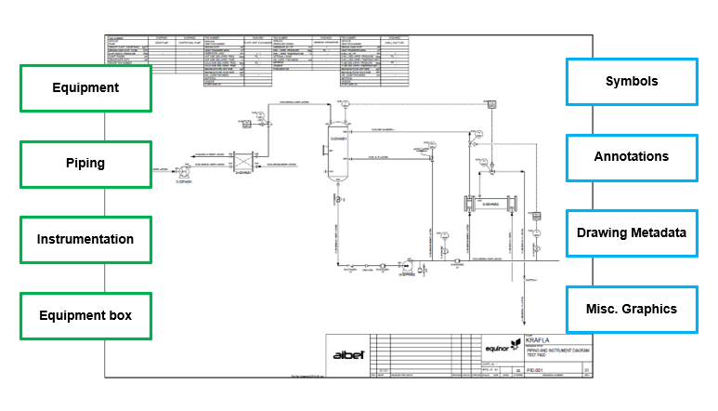
Figure 1: P&ID DISC DEXPI breakdown

P&ID Example C01_NOA1 June MileStone Example
As part of the DEXPI initiative the following example P&ID drawing has been provided. This drawing shall be reproduced in each of the drawing tools as shown in the example below and shall be used as the DEXPI export/import example to demonstrate compliance with the June 2022 milestone requirements.
All symbols shall be shown in the rotation, placement, naming and label placement as below.
**Note: colour has been used to indicate instrument bubbles used for labels (black) vs field instruments (green). Colour information is NOT required in the DEXPI transfer or example file details.

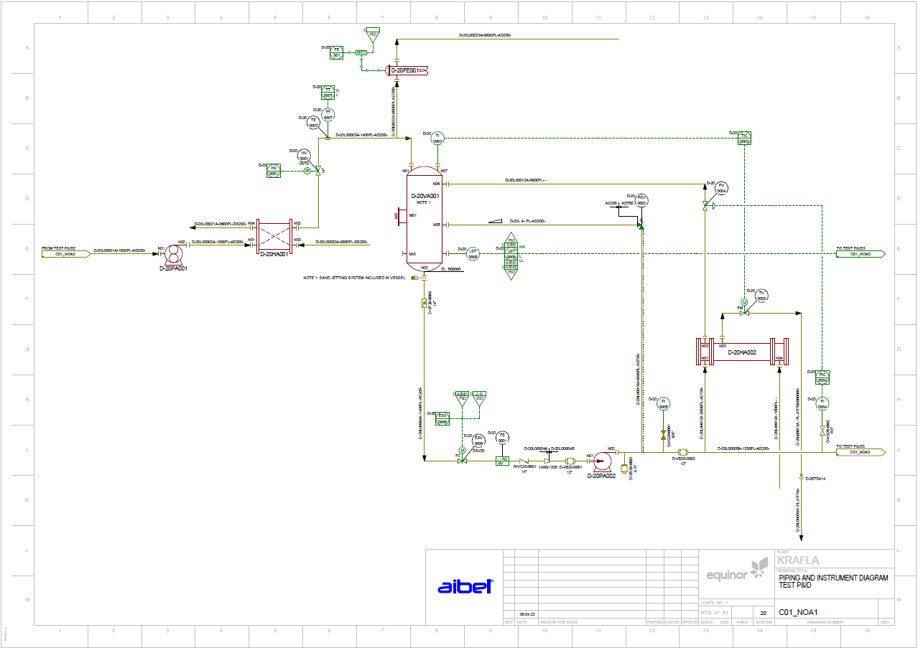
Figure 2: Example C01_NOA1 (June milestone)

DEXPI Standard
The DEXPI P&ID Specification defines an information model for P&IDs as well as a mapping to the exchange format. The current version of DEXPI P&ID 1.4 is serialized using the Proteus Schema. The upcoming version DEXPI 2.0 will be serialized using a new schema with a current working title ‘DEXPI XML’.
**Note: DEXPI 2.0 and DEXPI 1.4 have the same conceptual model.
This transfer requirements document provides all transfer and configuration details based on the DEXPI 1.4/2.0 conceptual model and gives examples in both serialization formats (Proteus & DEXPI XML) where this is possible.

DEXPI 1.2 -> DEXPI 2.0 updates:
The DISC DEXPI project was originally based on DEXPI 1.2 for the requirements definition. The current requirements document, however, is aligned with the DEXPI 1.4/2.0 conceptual model. Accordingly, the principal differences between versions 1.2 and 1.4/2.0 are identified and summarized below:
Changes to the DEXPI standard from 1.2 to 1.4/2.0 include these relevant items:
- Units of measurement cleaned up
- More comprehensive specification of graphics
- PropertyBreak class changed to PipingNetworkSegmentItem subtype
- Introduction of CustomClass and CustomAttribute elements
- Introduction of TransmissionSystem / TransmissionDriver to model link between motors and equipment
- Addition of:
  - Note class type
  - Mount class type
  - AccessNozzle subtype
  - Sensorwell class type
- Renaming of:
  - CustomInlineMeasuringElement -> CustomInlineMeasuringElement

Analysis:
Early analysis of the DEXPI 2.0 conceptual model and early pre-release version of the DEXPI XML serialization format indicate that weaknesses identified in the earlier project using DEXPI 1.3 have been addressed.
These weaknesses included:
Engineering Notes not part of the conceptual model: Note class is now part of the new conceptual model.
Object Symbol References restricted to one symbol reference per object: new serialization format supports multiple symbol references.
Offline signal references and multifile support: new serialization format supports multiple file transfer. The DEXPI 2.0 conceptual model for multiple file transfer support is still under discussion for the best way forward.

Transfer Requirements
Within the DISC DEXPI project it has been decided that the symbols shall form the basis of the mapping toward DEXPI to support the initial decision that we shall only transfer the graphical information from the P&ID in the DEXPI transfer file.
The DISC DEXPI project requires that each equipment object displayed on the P&ID shall be transferred within the DEXPI format with the required class mapping, symbol reference ID mapping, attribute mapping and association references to the piping / instrumentation systems as shown on the P&ID. The following sections provide details for the class and attribute mapping and implementation of the standard to reflect DISC process engineering drafting standards and symbols. Any additional rules or assumptions to be applied will also be noted in these sections.
General Requirement Details:
- PersistentID referencing shall be used to uniquely identify each class object. The context given within the PersistentID shall include a reference to the exporting application.
- DexpiCustomAttributes shall be used as the GenericAttributes ‘Set’ value within the Proteus export to group custom attributes that are defined within ANNEX B: Custom attribute defintions
- All Dexpi custom class definitions (DEXPI CustomObject subtypes) must use the DEXPI TypeName and TypeURI attributes as part of the class element transfer to provide the type details for the object. TypeName & TypeURI are provided in the symbol legend mapping.

Symbols
The DISC DEXPI symbol legend is based on Z004 NORSOK standard with some additions to support the DEXPI transfer, this project symbol legend is referred to as the DISC DEXPI symbol legend.
All symbols within this legend are mapped to a corresponding DEXPI class definition including any additional attributes to support the definition of the object.
A key feature of the DISC DEXPI symbol legend is the addition of a defined origo point for all symbols and the inclusion of the label as part of the overall graphic. A standard origo point definition across DISC will ensure correct placement of the symbol based on a single point element (x,y) for the shape in the transfer file.
The origo point placement is based on a few general rules:
- In-line components with 2 connectors the origo is placed on the center of the line transecting the symbol along the plane of the to-be connected pipeline to ensure ease of rotation on the pipeline and ease of substitution for intelligent attribute based symbols.
- In-line components with 3 or 4 connectors the origo is placed at the intersection point of the connectors
- In-line components with 1 connection point the origo is placed at the connection point
 |  |  |  |  |  |  |  |  | Label Details | Label Attribute(s) | Options
DEXPI ID | Graphic | Description | Rotation | Mirroring | ResizingX | ResizingY | TR1970 | Z004 | Symbol | A | 1
ND0011 | 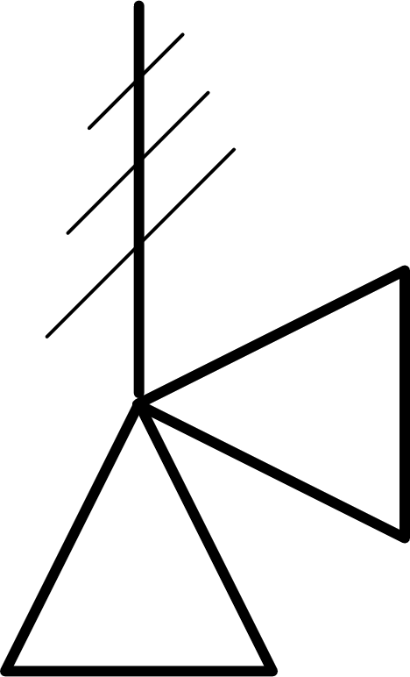 | Spring Actuated Safety Valve | Yes | Yes | No | No |  |  | IM005A
PV019A |  | Valve Ball | Yes | Yes | No | No | STLV008 | PV019A |  | <ObjectDisplayName> | ValvePosition = 'NC'

Requirement Details:
- SymbolRegistrationNumber attribute within the Shape element shall be used to provide the reference to the DISC DEXPI symbol reference ID.
- Name attribute of the Shape element shall be used as an internal file identifier to link the Shape symbol reference of the object to the Graphical representation instance of the object. Name is implemented in Proteus using ComponentName attribute.
- Location of the instance shall be given by the Shape Usage (Position / Reference) attributes for X & Y axiis. The X & Y points are the location reference to the origo of the symbol as defined in the symbol library for the project.
- Project shall use Label type ‘TagNameLabel’ for any item labels that are represented by a symbol e.g. for SafetyReliefValve.
  - Note: for most symbols the label is defined as part of the overall graphic. Ref [7]
- Transformation definition for the symbol shall use the definitions and rules as defined within the DEXPI standard (This is described in Ref [6] p. 19). Although any rotation shall be allowed and possible to transfer in the DEXPI file it is preferrable that only 0,90,180 & 270 deg anti-clockwise rotation of the symbol is used.
  - X-axis mirroring is provided for within DEXPI through the combination of attributes: ‘IsMirrored=True’ and ‘Rotation=180.0’ as per example (Ref: ANNEX D: Symbol Rotation and mirroring)
- Target application shall apply functionality to ensure that any text given as part of the overall symbol is displayed from left-to-right or bottom-to-top based on the rotation of the graphic.
- Target application shall use the rotation values from the transfer file and interpret the information to ensure graphical best fit with a focus on ensuring any symbol rotation transferred can be imported and displayed.
- All connection points shall be on the grid. This will ensure correct placement and management of the drawing connections for import.
- Symbol scaling shall be given by the ScaleX and ScaleY attribute of the DEXPI ShapeUsage element (implemented by the Proteus Scale element X and Y attributes)

DEXPI Model Examples

DEXPI w/ Proteus implementation: Shape SymbolRegistrationNumber
Ref: Proteus Example

DEXPI definition |  | Proteus Implementation
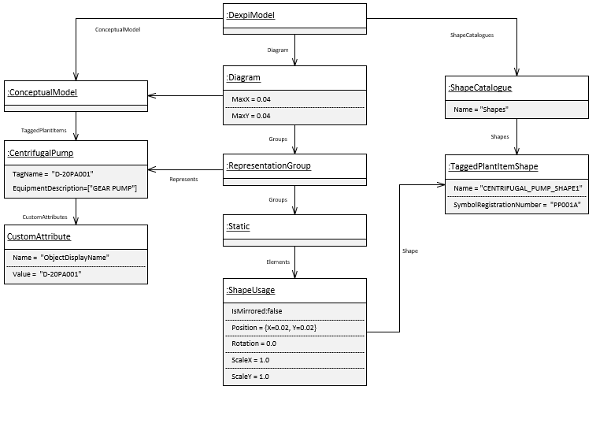  Figure 3: DEXPI Shape SymbolRegistrationNumber |  | 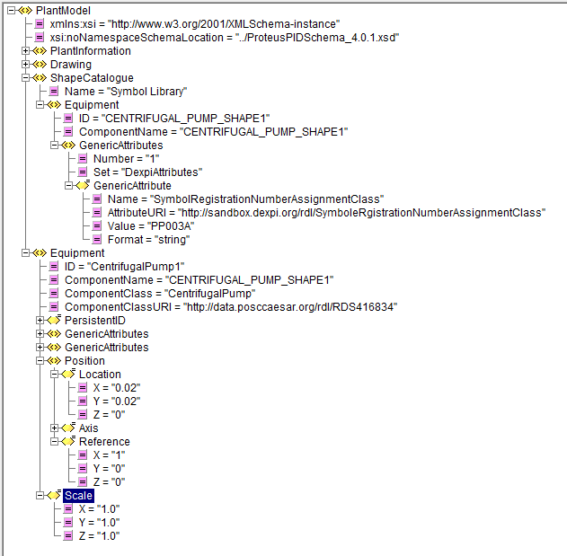  Figure 4: Proteus Implementation SymbolRegistrationNumberAssignmentClass

DEXPI Model: Shape with label symbol
DEXPI definition |  | Proteus Implementation
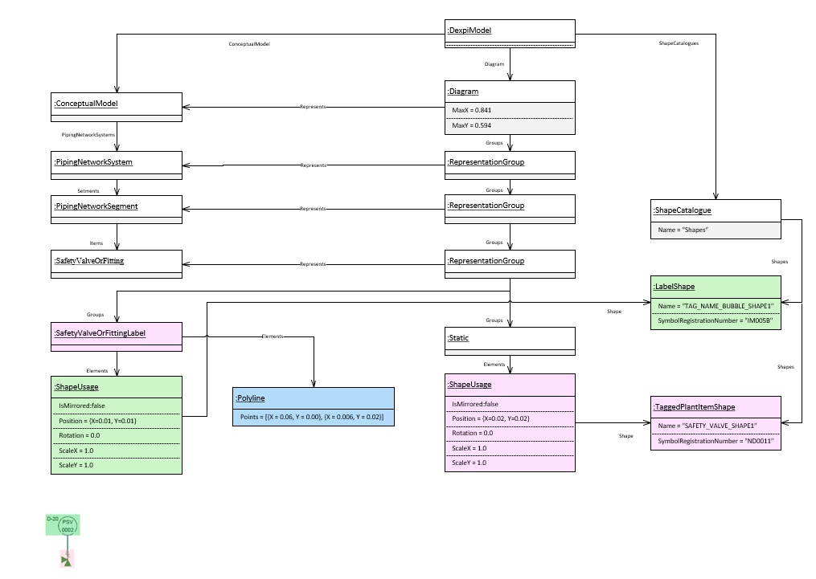  Figure 5: DEXPI model example Safety Valve Label Symbol Reference |  | 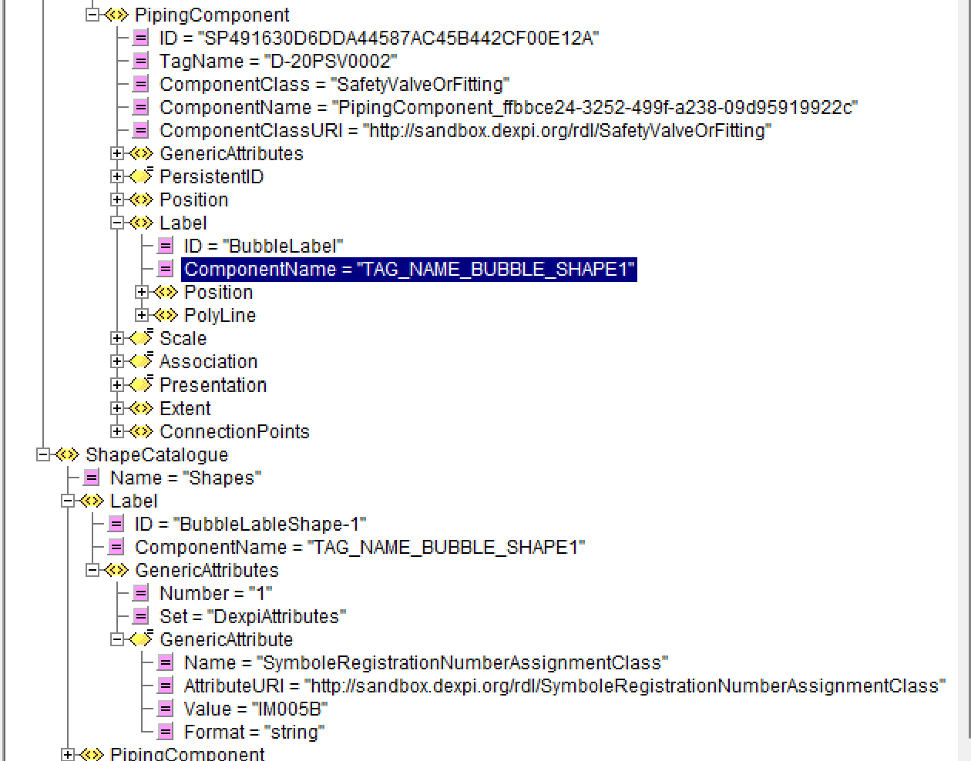  Figure 6: Proteus Implementation SymbolRegistrationNumberAssignmentClass for label

Persistent ID
- The following cases have been discussed and agreed upon for this revision:
Case | Persistent ID required?
• Plant Break Down Structure Items e.g. Plant, System, Area | • Yes
• Tagged Items (created within the Contractors system) | • Yes
• Tagged Items (bulk created and reserved within Equinor STID) | • Yes
• Untagged items that are part of the process and are graphically represented on the P&ID e.g. flange, nozzle | • Yes
• Untagged items that are NOT notes or part of the process and are graphically reqresented on the P&ID e.g. property breaks, flow direction, elevation, labels. | • No
• Untagged Items using commonly accepted rules to group: e.g. Loop | • Yes for the example given
• Untagged Items used to group based on internal rules (that are not common across systems) e.g. DEXPI PipingNetworkSegment | • Persistent ID for PipingNetworkSystem.
 | • No persistent ID for PipingNetworkSegment or Pipe (Centerline). Reassess after creating/applying update use cases.
• Items without graphical representation on the P&ID created ‘on the fly’ during export as required by DEXPI which contain process related information e.g. SignalConveyingFunction (used for alarms) | • Yes
• Items without graphical representation on the P&ID created ‘on the fly’ during export as required by DEXPI which contain NO process related information e.g. VirtualPipingConnector, ProcessSignalGeneratingFunction | • No reassess after update use cases.
• MeasuringLineFunction | • No not required
• Notes | • Yes

- Using the definitions from the cases above persistent ID requirements for the DEXPI class types are defined as follows:
DEXPI class type | Comment | Persistent ID
PlantStructureItem | All subtypes which are included in the export | Required
Note |  | Required
PipeOffPageConnector |  | Required
SignalOffPageConnector |  | Required
Equipment | All subtypes which have a representation on the P&ID | Required
Nozzle | NOT included: items with IsVirtual=TRUE | Required
PipingNetworkSystem |  | Required
PipingComponent | All subtypes which have a representation on the P&ID.  NOT included: VirtualPipingConector | Required
ControlledActuator |  | Required
ProcessInstrumentationFunction |  | Required
InstrumentationLoopFunction |  | Required
SignalConveyingFunction | NOT included: MeasuringLineFunction | Required
PipingNetworkSegment |  | Not Required
PipingConnection |  | Not Required
MeasuringLineFunction |  | Not Required
ActuatingElectricalFunction |  | Not Required
ActuatingSystem |  | Not Required
ActuatingFunction |  | Not Required
ProcessSignalGeneratingFunction |  | Not Required
ProcessSignalGeneratingSystem |  | Not Required
SensingLocation |  | Not Required
PropertyBreak |  | Not Required
OperatedValveReference |  | Not Required
PipingNode |  | Not Required
Pipe |  | Not Required

File & Drawing Metadata
File and Drawing Metadata are the high-level data used to give information about the file itself and also drawing top level details. Many of the MetaData attribute are part of the drawing template as shown below:

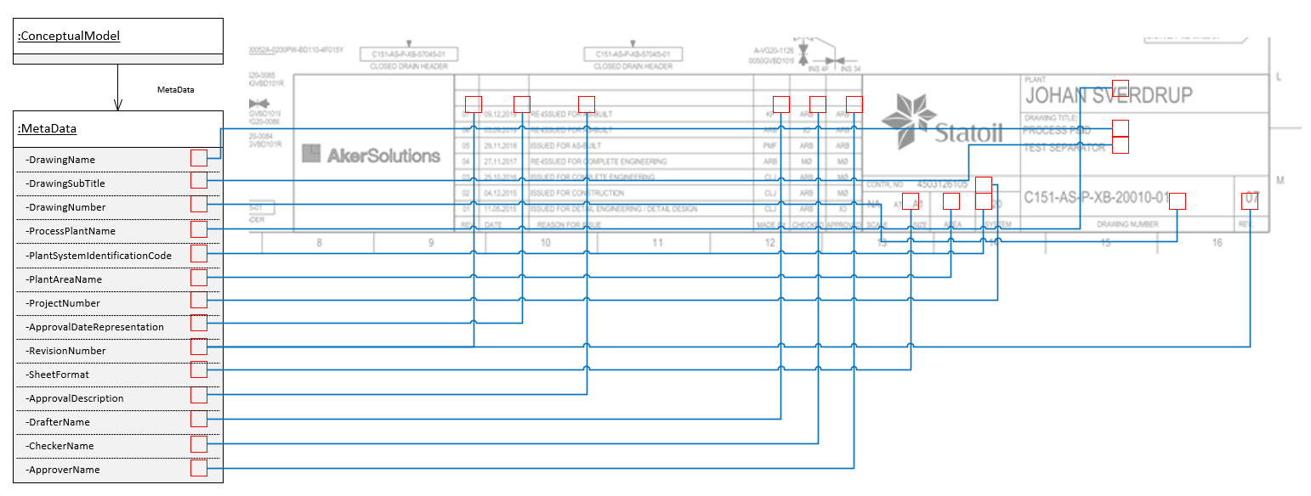
Figure 7: DEXPI MetaData model example

Requirement Details

DEXPI XML:
TBD

Proteus Serialization:
- Only current revision information shall be transferred in the export file.
- File encoding shall be ‘utf-8’
- Each DEXPI transfer file shall include the following PlantModel XML attribute(s)
Attribute | Comment | Value
schemaLocation | Proteus schema location | URL reference to xsd file matching SchemaVersion
- Each DEXPI transfer file shall include the following PlantInformation XML attributes
Attribute | Comment | Value
SchemaVersion | Proteus schema version | 4.1.1
Date | Export UTC date format yyyy-mm-dd
Time | Export UTC time format HH:mm:ss
Units | Unit of measure reference for all measurement values (used in the Verificator)
ApplicationVersion | DEXPI standard | 2.0

Drawing Metadata:
- Each DEXPI transfer file shall include the following attributes as part of the drawing metadata element:

Attribute | RDS | Value Example | Comment
ApprovalDateRepresentation | http://sandbox.dexpi.org/rdl/ApprovalDateRepresentationAssignmentClass
ApprovalDescription | http://sandbox.dexpi.org/rdl/ApprovalDescriptionAssignmentClass
ApproverName | http://sandbox.dexpi.org/rdl/ApproverNameAssignmentClass
CheckerName | http://sandbox.dexpi.org/rdl/CheckerNameAssignmentClass
DrafterName | http://sandbox.dexpi.org/rdl/DrafterNameAssignmentClass |  | P&ID drafter user ID
DrawingName | http://data.posccaesar.org/rdl/RDS2102503531 | PIPING AND INSTRUMENT DIAGRAM
DrawingNumber | http://sandbox.dexpi.org/rdl/DrawingNumberAssignmentClass | PID.001
DrawingSubTitle | http://sandbox.dexpi.org/rdl/DrawingSubTitleAssignmentClass | TEST P&ID
PlantAreaName | http://sandbox.dexpi.org/rdl/AreaIsa95NameAssignmentClass
PlantSystemIdentificationCode | http://sandbox.dexpi.org/rdl/PlantSystemIdentificationCodeAssignmentClass | 20
ProcessPlantIdentificationCode | http://sandbox.dexpi.org/rdl/ProcessPlantIdentificationCodeAssignmentClass | D
ProcessPlantName | http://sandbox.dexpi.org/rdl/ProcessPlantNameAssignmentClass | KRAFLA
ProjectNumber | http://sandbox.dexpi.org/rdl/ProjectNumberAssignmentClass
RevisionNumber | http://sandbox.dexpi.org/rdl/RevisionNumberAssignmentClass | 01
SheetFormat | http://sandbox.dexpi.org/rdl/SheetFormatAssignmentClass | NTS at A1
CreatorName | http://sandbox.dexpi.org/rdl/CreatorNameAssignmentClass |  | User ID of person exporting P&ID to DEXPI

Process Plant, Plant System & Plant Area
System numbering codes and plant area codes are both given on the P&ID to provide information about the engineering elements. DEXPI provides for the transfer of these elements via the PlantSystem & PlantArea class definitions.

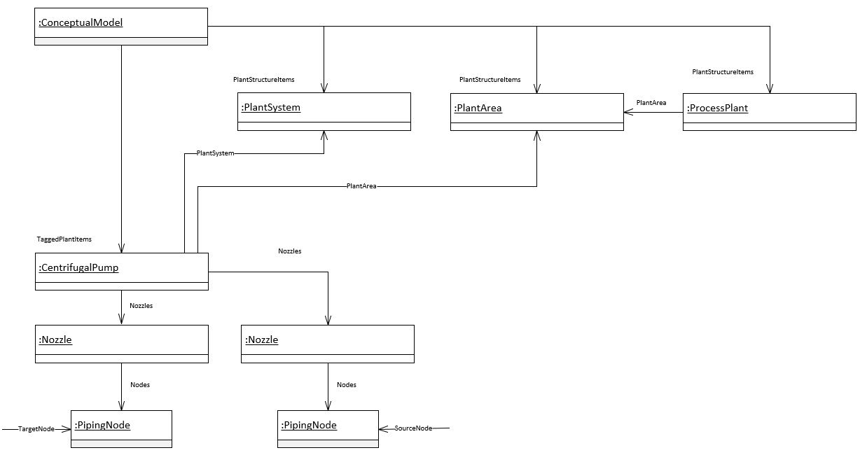
Figure 8: DEXPI ProcesPlant, PlantSystem & PlantArea model example

Requirement Details:
- ProcessPlant class shall be transferred.
- Each ProcessPlant DEXPI transfer object shall include the following attributes:
Attribute | RDS | Value Example | Comment
ProcessPlantIdentificationCode | http://sandbox.dexpi.org/rdl/ProcessPlantIdentificationCodeAssignmentClass | D | Plant code
- PlantSystem association shall be used where this information is available for an item.
- Each PlantSystem DEXPI transfer object shall include the following attributes:
Attribute | RDS | Value Example | Comment
PlantSystemIdentificationCode | http://sandbox.dexpi.org/rdl/PlantSystemIdentificationCodeAssignmentClass | 20 | System code associated with the item

- PlantArea association shall be used where this information is available for an item.
- Each PlantArea DEXPI transfer object shall include the following attributes:
Attribute | RDS | Value Example | Comment
PlantAreaIdentificationCode | http://sandbox.dexpi.org/rdl/PlantAreaIdentificationCodeAssignmentClass | B23 | Area code associated with the item

Equipment

Main Equipment
Equipment is the main items shown in a P&ID to perform the process required treatment. The plant equipment is shown in the P&ID by an icon showing the equipment in basic manner. Equipment is usually identified by a name and unique tag (Unique identifier that is assigned to a field device, skid or equipment).
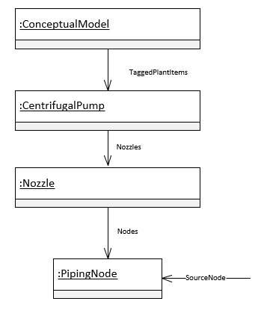
Figure 9: DEXPI Equipment model example

Requirement Details:
- Direct connections between Equipment shall be identified within the DEXPI transfer file by transferring the secondary equipment (e.g. motor) unique ID value in the ConnectedEquipment attribute on the primary equipment (e.g. pump) element.
- Each Equipment DEXPI transfer object shall include the following attributes when available:

Attribute | RDS | Value Example | Comment
ConnectedEquipmentID | http://noaka.org/rdl/ConnectedEquipmentIDAssignmentClass |  | Proteus XML ID value of the connected equipment element
ObjectDisplayName | http://noaka.org/rdl/ObjectDisplayNameAssignmentClass | D-20PA001 | Label text as displayed on the P&ID
Sequence | http://noaka.org/rdl/SequenceAssignmentClass | 001 | Sequence number which is part of the tag name.
TagType | http://noaka.org/rdl/TagTypeAssignmentClass | PA | Letter code indicating the function of the item.
EquipmentDescription | http://data.posccaesar.org/rdl/RDS2181987301 | GEAR PUMP | Functional service description of the tagged item.
TagName | http://sandbox.dexpi.org/rdl/TagNameAssignmentClass | D-20PA001 | Tag name as stored in the tag register system.
Elevation | http://noaka.org/rdl/ElevationAssignmentClass | EL. 400000 | Elevation information for the equipment.

- For each Equipment DEXPI transfer object represented by a symbol with an type code text component shall include the following attribute:
Attribute | RDS | Value Example | Comment
TypeCode | http://noaka.org/rdl/TypeCodeAssignmentClass | E | Text code to be displayed within the symbol. Ref: [7] ‘Label Attributes’

Connnected Equipment
Main equipment such as pumps are sometimes drafted with a connected driver on the P&ID. It is important to be able to capture this relationship for design and maintenance. Within DEXPI 1.4 this relationship is captured using the TransmissionSystem conceptual data model.
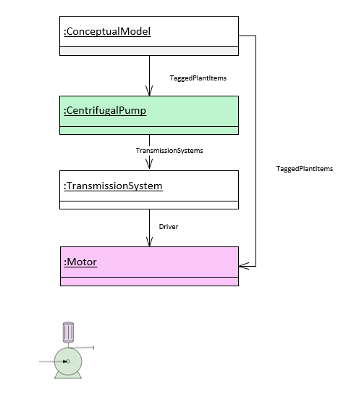
Figure 10: DEXPI Connected Equipment model example

Requirement Details:
- Direct connections between a driver type equipment and a driven type equipment e.g. motor and pump or motor and compressor shall use the TransmissionSystem conceptual modelling approach as shown above.

Piping
A Piping System is an assembly of various components put together with a proper method of joints, functionally to transport fluid from its source to destination. The different components put together are defined as piping components. They are designed for withstanding the operating and design conditions specified in the process parameters. The following sub-sections detail specific subsets of requirements based on component group types within the piping system.
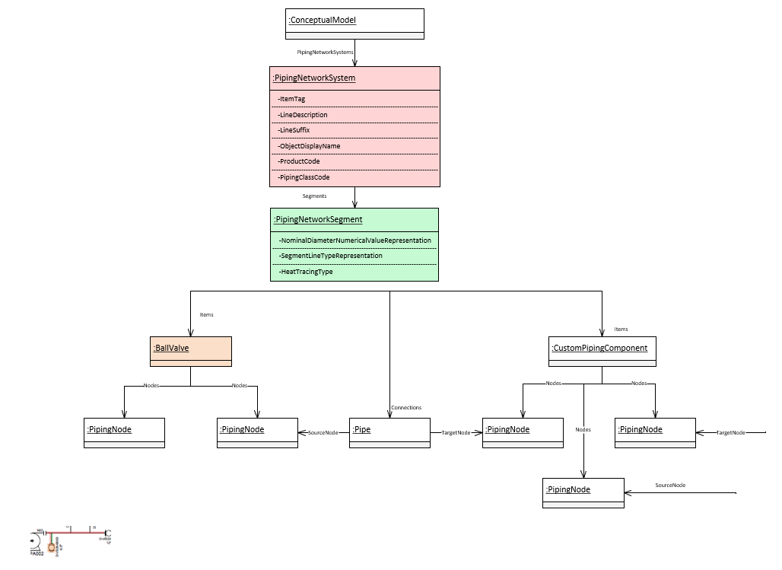
Figure 11: DEXPI PipingNetworkSystem model example

Piping
This sub-section details the transfer requirements related to the PipingNetworkSystem, PipingNetWorkSegment and Pipe elements.

Requirement Details:
- Each pipeline shall be represented by a separate PipingNetworkSystem
- PipingNetworkSystems shall contain all PipingNetworkSegments that share the same pipeline name ‘ItemTag’ attribute value.
- Each pipeline shall contain one or more PipingNetworkSegments where the topology of the PipingNetworkSegments is defined in ANNEX C: Draft update ‘P&ID Profile file specification 3.3.3’
- Where heat tracing is utilized, this information shall be transferred via DEXPI using the HeatTracingType attribute on the PipingNetworkSegment. All elements within the PipingNetworkSegment shall inherit the heat tracing setting using one of the following values:
  - NULL: heat tracing system has not yet been evaluated
  - HeatTracingSystem: Heat tracing will be used on the piping network system
  - NoHeatTracingSystem: Heat tracing will not be used on the piping network system
- Piping connections shall be defined within the Proteus export file as per the Piping Connector details in ANNEX G: Proteus Connection Points & Associations
- Each PipingNetworkSystem DEXPI transfer object shall include the following attributes:
Attribute | RDS | Value Example | Comment
ItemTag | http://noaka.org/rdl/ItemTagAssignmentClass | D-20L00001A | The pipeline tag number.
LineDescription | http://noaka.org/rdl/LineDescriptionAssignmentClass | D-20L00001A-1800PL-AD200- | Complete Line number as indicated on the P&ID.
LineSuffix | http://noaka.org/rdl/LineSuffixAssignmentClass | A | Size indicator suffix
ObjectDisplayName | http://noaka.org/rdl/ObjectDisplayNameAssignmentClass | D-20L00001A-1800PL-AD200- | Label text as displayed on the P&ID
ProductCode | http://noaka.org/rdl/ProductCodeAssignmentClass | PL | Product service code for the line
PipingClassCode | http://sandbox.dexpi.org/rdl/PipingClassCodeAssignmentClass | AD750 | Piping class for the line
HeatTracingRequirement | http://noaka.org/rdl/HeatTraceRequiredAssignmentClass | Y/N/S | Is heat tracing required for some/all of the pipeline: Y-Yes; N-No; S-Safety critical
- Each PipingNetworkSegment DEXPI transfer object shall include the following attributes:
Attribute | RDS | Value Example | Comment
ItemTag | http://noaka.org/rdl/ItemTagAssignmentClass | D-20L00001A | The pipeline tag number.
SegmentLineTypeRepresentation | http://noaka.org/rdl/ SegmentLineTypeRepresentationAssignmentClass | Primary/Secondary/Utility | Indicate line type to use
HeatTracingType | http://sandbox.dexpi.org/rdl/HeatTracingTypeSpecialization | NoHeatTracingSystem | Indicates that no heat tracing is used.
NominalDiameterNumericalValueRepresentation | http://sandbox.dexpi.org/rdl/ NominalDiameterNumericalValueRepresentationAssignmentClass | 800 | Nominal diameter for the line

Piping Components
Piping components are those components that are connected in-line with the pipe to support the transport of fluid from its source to destination. Piping components referred to in this section can be (but are not limited to) one of the following types:
- Pipe fittings
- Flanges
- Gaskets
- Manually Operated Valves
- Special Items
- Nozzles
- Reducers
The Piping Components group as discussed here does not include pipes, safety valves or actuated valves. Safety valves and actuated valves are detailed in Instrumentation section.

Requirement Details:
- NozzleTee symbol shall be used to represent all nozzles on the P&ID
- Where a nozzle has not been included on the drawing between the equipment and the pipe/measuring line the transfer shall include a ‘virtual’ nozzle to ensure compliance with DEXPI. A ‘virtual’ nozzle shall be identified using the Nozzle custom attribute ‘IsVirtual= TRUE (Ref: ANNEX B: Custom attribute defintions)
- BlindFlange DEXPI class mapping shall be used in the transfer file for the flange where there is one PipingNode connection
- Flange DEXPI class mapping shall be used in the transfer file for the flange where there are two PipingNode connections.
- VirtualPipingConnector custom class shall be used to provide for direct pipe to pipe connections i.e., where there is no graphical representation of a connecting piping compontent between the two pipes shown on the P&ID. (Ref: Virtual Piping Connector)

- Each PipingComponent DEXPI transfer object shall include the following attributes when available/applicable:

Attribute | RDS | Value Example | Comment
ItemTag | http://noaka.org/rdl/ItemTagAssignmentClass | D-VB20-0002 | Tag name as stored in the tag register
ObjectDisplayName | http://noaka.org/rdl/ObjectDisplayNameAssignmentClass | D-VB20-0002 | Label text as displayed on the P&ID
Sequence | http://noaka.org/rdl/SequenceAssignmentClass | 0002 | Sequence number which is part of the tag number.
TagType | http://noaka.org/rdl/TagTypeAssignmentClass | VB | Letter code indicating the function of the item.

- For each PipingComponent DEXPI transfer object that is of type OperatedValve (or sub-type) shall include the following attributes in addition to the attributes defined in the table above when available. In the main these attributes will be used within the label for the Valve (Ref: ANNEX F: Valve Label Details)

Attribute | RDS | Value Example | Comment
ValvePosition | http://noaka.org/rdl/ValvePositionAssignmentClass | NC | Valve Normal Position: Used to define how the graphics for the valve shall be displayed (e.g. black/closed or white/open)  Symbol options provided in the symbol library show how this will be represented. Ref [7]
VDS | http://noaka.org/rdl/VDSAssignmentClass | BMBD101R | Valve Data Sheet
NominalDiameter | http://noaka.org/rdl/NominalDiameterAssignmentClass | 0200 | Nominal diameter of the valve
TrimType | http://noaka.org/rdl/TrimTypeAssignmentClass | FB | Trim Type: e.g. Full Bore / Reduced Bore
LockMechanism | http://noaka.org/rdl/LockMechanismAssignmentClass | CSO | Lock Mechanism code
BarrierInformationFlowIn | http://noaka.org/rdl/BarrierInformationFlowInAssignmentClass | DP | Barrier Information e.g. DP (double piston) for the flow in side of the valve
BarrierInformationFlowOut | http://noaka.org/rdl/BarrierInformationFlowOutAssignmentClass | SR | Barrier Information e.g. SR (Self Relief) for the flow out side of the valve
TypicalReference | http://sandbox.dexpi.org/rdl/TypicalReferenceAssignmentClass |  | Code identifying the associated Typical if part of an actuated system.

- Each Nozzle DEXPI transfer object shall include the following attributes when available/applicable:

Attribute | RDS | Value Example | Comment
IsVirtual | http://noaka.org/rdl/IsVirtualAssignmentClass | TRUE | Set to ‘TRUE’ if the Nozzle is included in the DEXPI modelling but does not have a graphical representation on the drawing.
IsVirtualMount | http://noaka.org/rdl/IsVirtualMountAssignmentClass | FALSE | Set to ‘TRUE’ if the Nozzle is included is representing an external mounting on the equipment.
ItemTag | http://noaka.org/rdl/ItemTagAssignmentClass | M01 | Tag name as stored in the tag register
ObjectDisplayName | http://noaka.org/rdl/ObjectDisplayNameAssignmentClass | M01 | Label text as displayed on the P&ID
Sequence | http://noaka.org/rdl/SequenceAssignmentClass | 01 | Sequence number which is part of the tag number.
TagType | http://noaka.org/rdl/TagTypeAssignmentClass | M | Letter code indicating the function of the item.

- For each PipingComponent DEXPI transfer object that is defined as a special item shall include the following attribute:

Attribute | RDS | Value Example | Comment
SpecialItemNumber | http://noaka.org/rdl/SpecialItemNumberAssignmentClass | 3029 | Text for special item identification to be shown in SpecialItem label.
- For each PipeReducer DEXPI transfer object shall include the following attributes when available/applicable:

Attribute | RDS | Value Example | Comment
NominalDiameterIn | http://noaka.org/rdl/NominalDiameterInAssignmentClass | 0100 | Nominal diameter into the reducer
NominalDiameterOut | http://noaka.org/rdl/NominalDiameterOutAssignmentClass | 0200 | Nominal diameter out of the reducer

Instrumentation
Instrumentation is the items shown in a P&ID required to run, monitor and control a specific process. E.g. Indicators, Recorders, Controllers , including: pressure, temperature and flow instruments, control valves, pressure safety valves, meters etc.

Instrumentation (Off-Line Instrumentation)
Ref: Protues Example
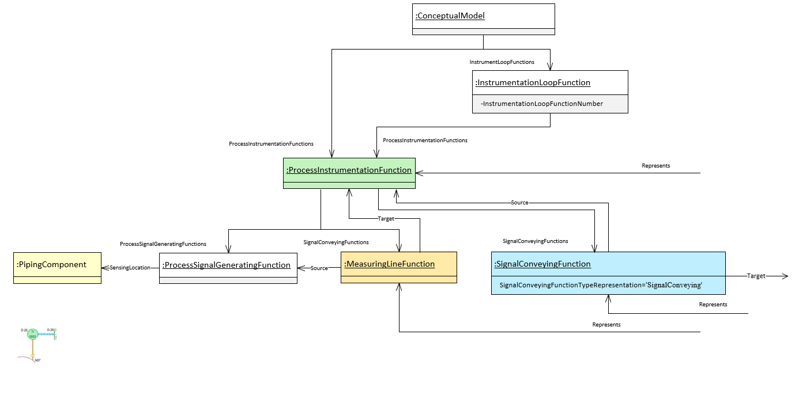
Figure 12:DEXPI Instrumentation model example within connection to PipingComponent (Flange)

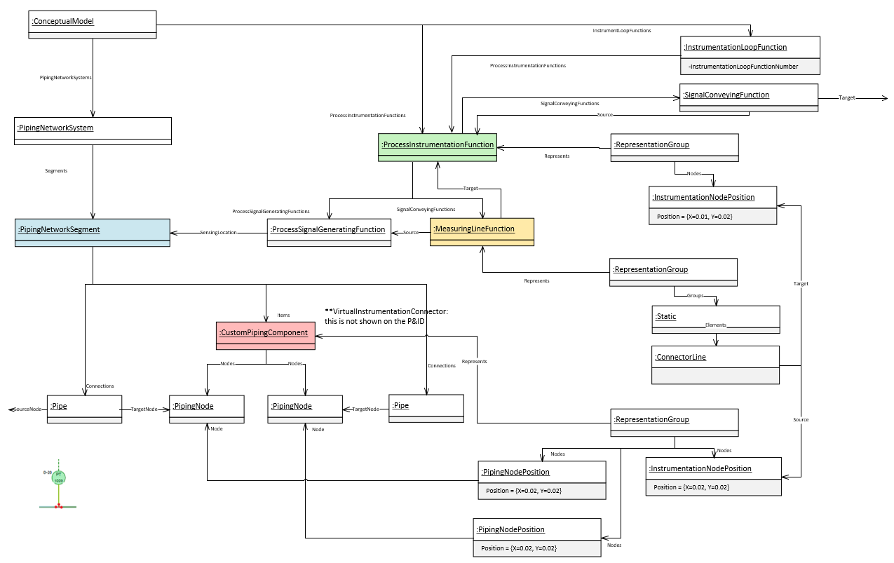
Figure 13:DEXPI Instrumentation model example within connection to PipingNetworkSegment and graphical connection nodes

Requirement Details:
- All instruments (not incl. actuated and safety valves) shall be represented by a ProcessInstrumentFunction (PIF) class element in DEXPI.
- InstrumentationLoopFunction class must be used as a 'grouping' mechanism for ProcessInstrumentFunction (PIF) elements where the loop identifier for those PIF items is known.
- InstrumentationLoopFunction class shall only be created in the export if there is an associated ProcessInstrumentationFunction class.
- Signal conveying lines shall be represented using DEXPI SignalConveyingFunction class using the SignalConveyingFunctionTypeRepresentation to define the line style Ref: [7] for valid type values.
- SignalConveyingFunction Parent shall be the ProcessInstrumentationFunction item associated with the ‘sending’ PIF. *Ensures consistency with cases where the PIF is associated with an ActuatingFunction.
- Measure lines between instrument and piping component shall be represented using MeasuringLineFunction class.
- DEXPI MeasuringLineFunction shall have an ProcessSignalGeneratingFunction as its Source
- DEXPI ProcessInstrumentationFunction reference shall contain a ProcessInstrumentationFunctionType descriptor attribute where both a field device and shared display/shared control element exists for the object and the tag name for these objects is the same.
- Instrumentation connections shall be defined within the Proteus export file as per the Instrument Connector details in ANNEX G: Proteus Connection Points & Associations
- The DEXPI SensingLocation for the DEXPI ProcessSignalGeneratingFunction shall be either Nozzle, PipingComponent or PipingNetworkSegment as per the DEXPI standard. In the case where an off-line instrument is drawn with a connection direct to a pipe the SensingLocation shall be set to PipingNetworkSegment.
- Each InstrumentationLoopFunction DEXPI transfer object shall include the following attributes when available:
Attribute | RDS | Value Example | Comment
InstrumentationLoopFunctionNumber | http://sandbox.dexpi.org/rdl/InstrumentationLoopFunctionNumberAssignmentClass | T0003 | Loop number use to group associated instruments.

- Each Instrument (PIF) shall include the following attributes when available:
Attribute | RDS | Value Example | Comment
ItemTag | http://noaka.org/rdl/ItemTagAssignmentClass | D-20TI-0003 | Tag name as stored in the tag register system.
ProcessInstrumentationFunctionLocation | http://noaka.org/rdl/ ProcessInstrumentationFunctionLocationAssignmentClass | Field / Primary / Auxiliary / Inaccessable | Location information for the instrument. Ref: Figure 14 for details regarding use of attribute for instrument symbols.
ProcessInstrumentationFunctionType | http://noaka.org/rdl/ ProcessInstrumentationFunctionTypeAssignmentClass | Discrete / SharedDisplaySharedControl | Differentiate between field device and control function block. Ref: Figure 14 for details regarding use of attribute for instrument symbols.
TagSuffix | http://noaka.org/rdl/TagSuffixAssignmentClass | A | Suffix code
ProcessInstrumentationFunctionCategory | http://sandbox.dexpi.org/rdl/ ProcessInstrumentationFunctionCategoryAssignmentClass | T | Function category
ProcessInstrumentationFunctionNumber | http://sandbox.dexpi.org/rdl/ ProcessInstrumentationFunctionNumberAssignmentClass | 0003 | Sequence number
ProcessInstrumentationFunctions | http://sandbox.dexpi.org/rdl/ ProcessInstrumentationFunctionsAssignmentClass | I | Additional functions
SetPointTemperature | http://noaka.org/rdl/SetPointTemperatureAssignmentClass | 100.0 DegreeCelsius | Temperature SetPoint value and UoM
SetPointGaugePressure | http://noaka.org/rdl/SetPointGaugePressureAssignmentClass | 17.0 Bar | Gauge Pressure SetPoint value and UoM
SetPointLength | http://noaka.org/rdl/SetPointLengthAssignmentClass | 20.0 Centimetre | Length SetPoint value and UoM
** The engineering naming system can sometimes allow for two instrument symbols (elements) to be given the same tag name even though they represent different functions. It is therefore key to include the above attributes, particularly the ProcessInstrumentationFunctionType attribute.

- For each ProcessInsrumentationFunction DEXPI transfer object represented by a symbol with an type code text component shall include the following attribute:
Attribute | RDS | Value Example | Comment
TypeCode | http://noaka.org/rdl/TypeCodeAssignmentClass | PSD | Text code to be displayed within the symbol. Ref: [7] ‘Label Attributes’ and Ref: Figure 14 for details regarding use of attribute for instrument symbols.

- Each SignalConveyingFunction DEXPI transfer object shall include the following attributes when available:
Attribute | RDS | Value Example | Comment
SignalConveyingFunctionTypeRepresentation | http://noaka.org/rdl/SignalConveyingFunctionTypeRepresentationAssignmentClass | SignalConveying | Linestyle type representation as defined in the Symbols legend for ‘SignalAndLineStyles’

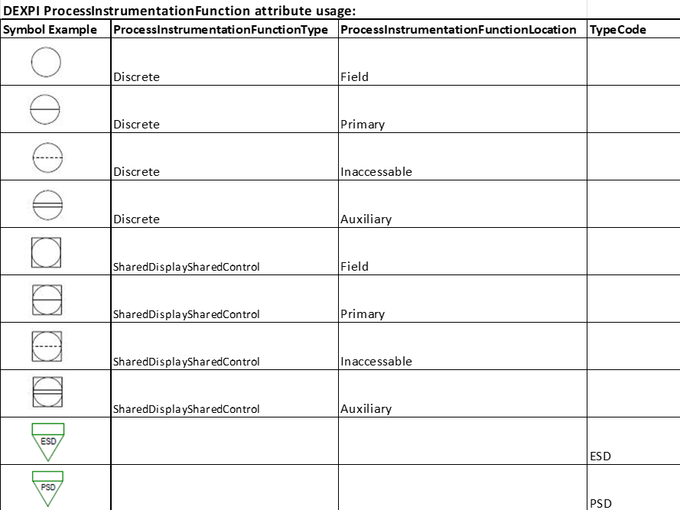

Figure 14: Instrumentation symbols with reference to ProcessInstrumentationFunctionType, ProcessInstrumentationFunctionLocation & TypeCode

Instrumentation (Off-Line instrument equipment-mounted)
Ref: TBD
The following section specifies additional modelling and DEXPI transfer requirements for equipment-mounted measuring instruments used for non-invasive measurements.
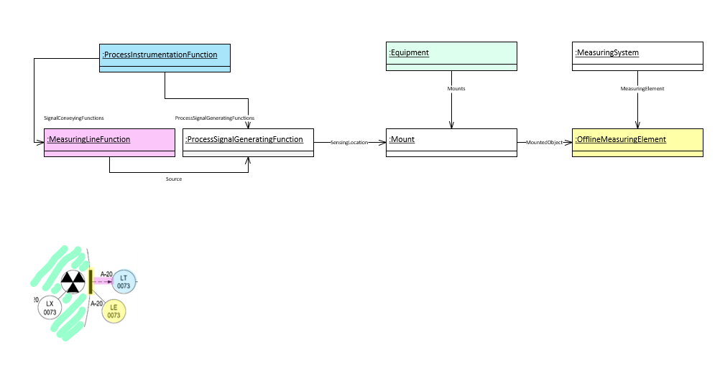
Figure 15: DEXPI Instrumentation (Off-Line instrument equipment-mounted) model

Requirement Details:
- Main requirement details are as per Ref: Instrumentation (Off-Line Instrumentation)
- Each OfflineMeasuringElement shall include the following attributes when available:
Attribute | RDS | Value Example | Comment
ItemTag | http://noaka.org/rdl/ItemTagAssignmentClass | D-20TI-0003 | Tag name as stored in the tag register system.
ProcessInstrumentationFunctionLocation | http://noaka.org/rdl/ ProcessInstrumentationFunctionLocationAssignmentClass | Field / Primary / Auxiliary / Inaccessable | Location information for the instrument. Ref: Figure 14 for details regarding use of attribute for instrument symbols.
ProcessInstrumentationFunctionType | http://noaka.org/rdl/ ProcessInstrumentationFunctionTypeAssignmentClass | Discrete / SharedDisplaySharedControl | Differentiate between field device and control function block. Ref: Figure 14 for details regarding use of attribute for instrument symbols.
TagSuffix | http://noaka.org/rdl/TagSuffixAssignmentClass | A | Suffix code
ProcessInstrumentationFunctionCategory | http://sandbox.dexpi.org/rdl/ ProcessInstrumentationFunctionCategoryAssignmentClass | T | Function category
ProcessInstrumentationFunctionNumber | http://sandbox.dexpi.org/rdl/ ProcessInstrumentationFunctionNumberAssignmentClass | 0003 | Sequence number
ProcessInstrumentationFunctions | http://sandbox.dexpi.org/rdl/ ProcessInstrumentationFunctionsAssignmentClass | I | Additional functions

Instrumentation (Off-Line instrument alarm and shut-down ‘cause’)
Ref: Protues Example
The following section details additional modelling and transfer requirements for instrument control functions that have alarm points and/or associated shutdown function(s).
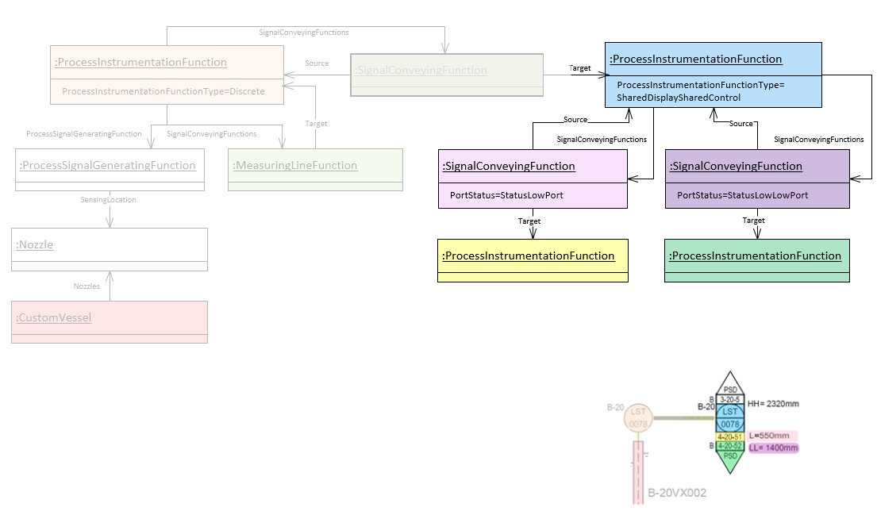
Figure 15: DEXPI Instrumentation Alarm & Shut-down ‘cause’ model

Requirement Details:
- Main requirement details are as per Ref: Instrumentation (Off-Line Instrumentation)
- Alarm levels shall be represented by DEXPI SignalConveyingFunction class type and shall include the following attributes:

Attribute | RDS | Value Example | Comment
PortStatus | http://sandbox.dexpi.org/rdl/PortStatusSpecialization | StatusLowLowPort | Alarm type

Instrumentation (Off-line Instrument shut-down ‘effect’ with multiple signal lines)
Ref: Protues Example
The following section details additional modelling and transfer requirements for instrument shutdown function(s) ‘effect’ elements.
Note: each shutdown ‘cause’ object may have one or more ‘effect’ objects.
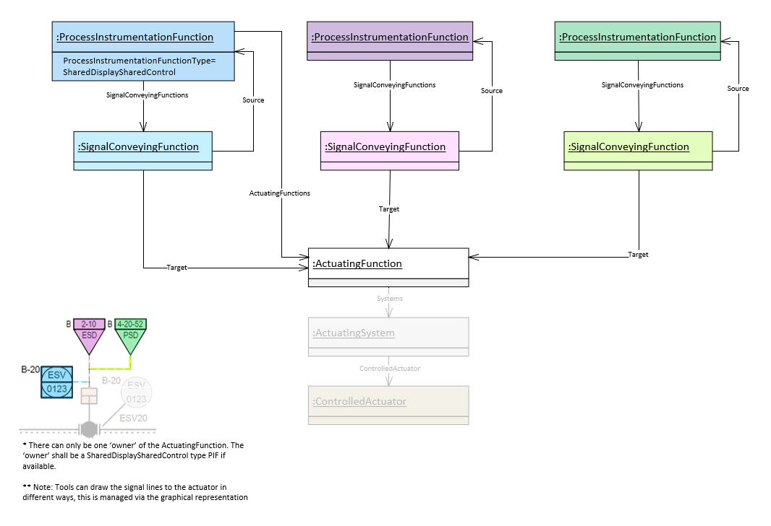
Figure 16: DEXPI Instrumentation Shut-down ‘effect’ model with multiple signal lines

Requirement Details:
- Main requirement details are as per Ref: Instrumentation (Off-Line Instrumentation)
- Where more than one signal is connected to an actuator the export system shall ensure that there is 1 ‘owner’ of the ActuatingFunction and that this shall be a SharedDisplaySharedControl type PIF if available.

Instrumentation Electrical Powered Equipment
Ref: Protues Example
This is a special grouping for electrical powered objects that receive/send signals from other electrical powered objects, controllers, shutdowns and equipment.

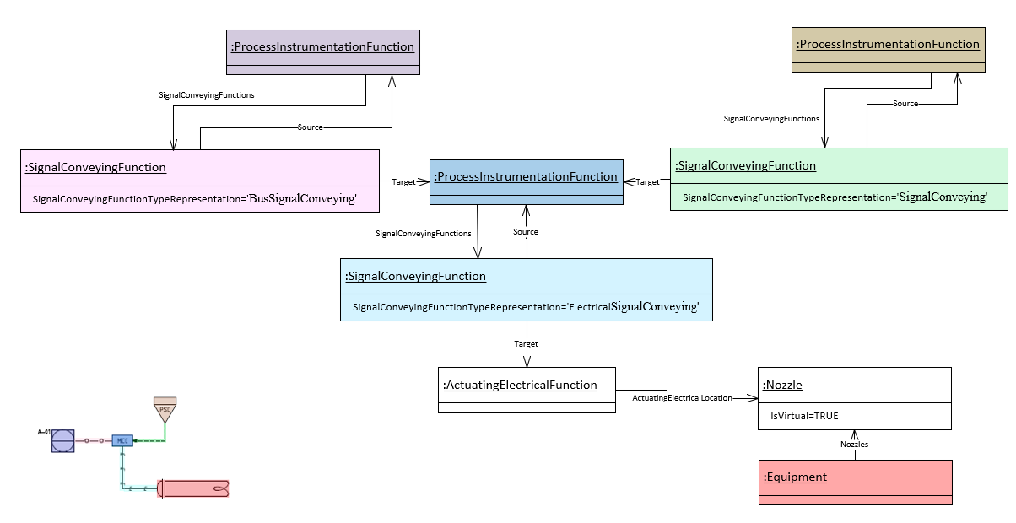
Figure 17: DEXPI Instrumentation Electrical Powered Equpment model

Requirement Details:
- Main requirement details are as per Ref: Instrumentation (Off-Line Instrumentation)
- Electrical signal lines between ‘instrument electrical powered equipment’ object and equipment shall be represented using SignalConveyingFunction class which has a DEXPI ActuatingElectricalFunction class as its Target.

Instrumentation (In-Line Instrumentation)
Ref: Protues Example
**Does not include instrument safety valves or actuated valves.
In-line instrumentation are those elements that are part of the piping network and provide an instrumentation function.

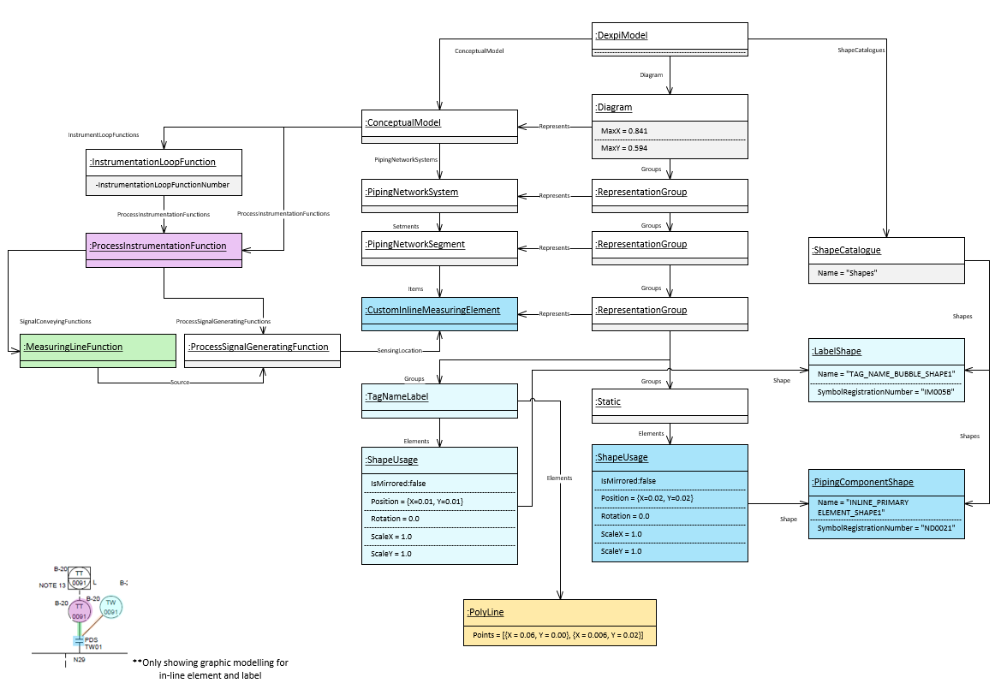
Figure 18: Example In-line thermowell with associated transmitter.

Requirement Details:
- In-line instrument on the P&ID shall be represented as both an in-line instrument and a separate off-line instrument as a ‘short-cut’ to allow for signal connections. In the case where a signal connection is required this shall be via a separate off-line instrument connected to the in-line instrument.
- All in-line instruments (not incl. actuated and safety valves) shall be represented by an InlineMeasuringElement (or subtype) class element in DEXPI.
- Measure lines between in-line instrument and off-line instrument shall be represented using MeasuringLineFunction class.
- DEXPI MeasuringLineFunction shall have an ProcessSignalGeneratingFunction as its Source

- Each DEXPI InlineMeasuringElement (or subtype) shall include the following attributes when available:
Attribute | RDS | Value Example | Comment
InlinePrimaryElementFunctionCategory | http://noaka.org/rdl/InlinePrimaryElementFunctionCategoryAssignmentClass | T | Function category
InlinePrimaryElementFunctions | http://noaka.org/rdl/InlinePrimaryElementFunctionsAssignmentClass | W | Additional functions
ItemTag | http://noaka.org/rdl/ItemTagAssignmentClass | D-20TI-0003 | Tag name as stored in the tag register system.
TagType | http://noaka.org/rdl/TagTypeAssignmentClass | TI | Letter code indicating the function of the item.
InstrumentLoopNumber | http://noaka.org/rdl/InstrumentLoopNumberAssignmentClass | T0003 | Loop number use to group associated instruments.

- For each InlineMeasuringElement DEXPI transfer object that is defined as a special item shall include the following attribute:
Attribute | RDS | Value Example | Comment
SpecialItemNumber | http://noaka.org/rdl/SpecialItemNumberAssignmentClass | 5068 | Text for special item identification to be shown in SpecialItem label.

Instrumentation (Safety and Self Acting Valves)
Instrumentation (Safety and Self-Acting Valves) shall be transferred as a DEXPI PipingComponent suptype within the DEXPI PipingNetworkSystem.
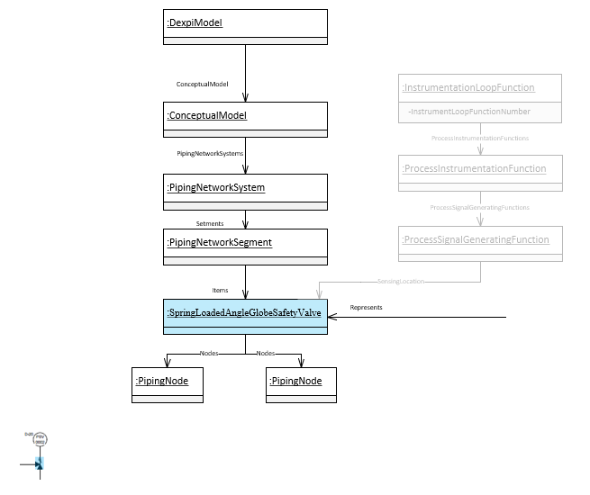
Figure 19: Instrumentation (Safety Valve) DEXPI model example

Requirement Details:
- Label symbol reference shall be transferred as a separate reference on the label element.
- Each DEXPI SafetyValveOrFitting (or subtype) shall include the following attributes when available:
Attribute | RDS | Value Example | Comment
ItemTag | http://noaka.org/rdl/ItemTagAssignmentClass | D-20PSV-0002 | Tag name as stored in the tag register system.
Sequence | http://noaka.org/rdl/SequenceAssignmentClass | 0002 | Sequence number which is part of the tag number.
TagType | http://noaka.org/rdl/TagTypeAssignmentClass | PSV | Letter code indicating the function of the item.
InstrumentLoopNumber | http://noaka.org/rdl/InstrumentLoopNumberAssignmentClass | P0002 | Loop number use to group associated instruments.
SetPointTemperature | http://noaka.org/rdl/SetPointTemperatureAssignmentClass | 100.0 DegreeCelsius | Temperature SetPoint value and UoM
SetPointGaugePressure | http://noaka.org/rdl/SetPointGaugePressureAssignmentClass | 17.0 Bar | Gauge Pressure SetPoint value and UoM
SetPointLength | http://noaka.org/rdl/SetPointLengthAssignmentClass | 20.0 Centimetre | Length SetPoint value and UoM

Instrumentation (Actuated Valves)
Ref: Protues Example
Actuated Valves are complex DEXPI structures as the valve is part of the piping package while instrumentation provides the automation. The special DEXPI modelling is shown below. Note that for actuated valves there are a number of RepresentationGroups required: including the representation for the valve, the actuator and the instrument bubble symbol.
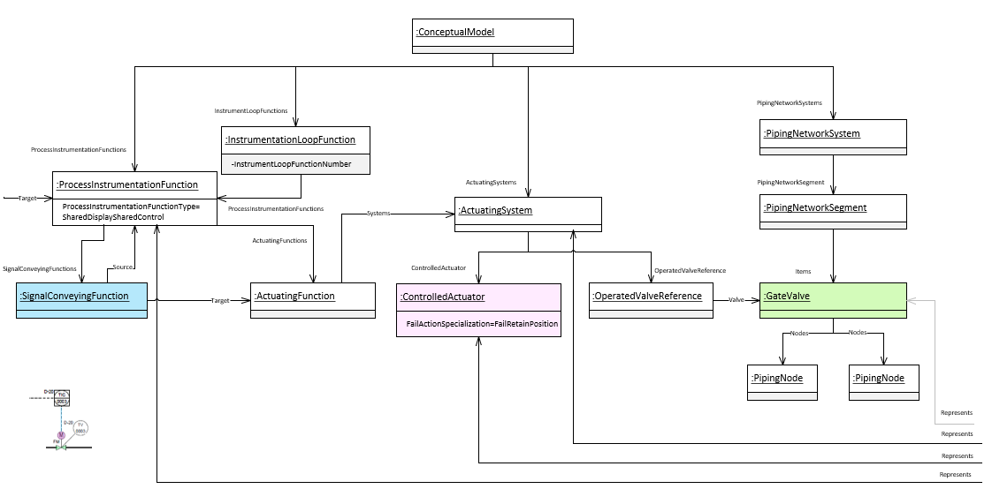
Figure 20: DEXPI Actuated Valve model example
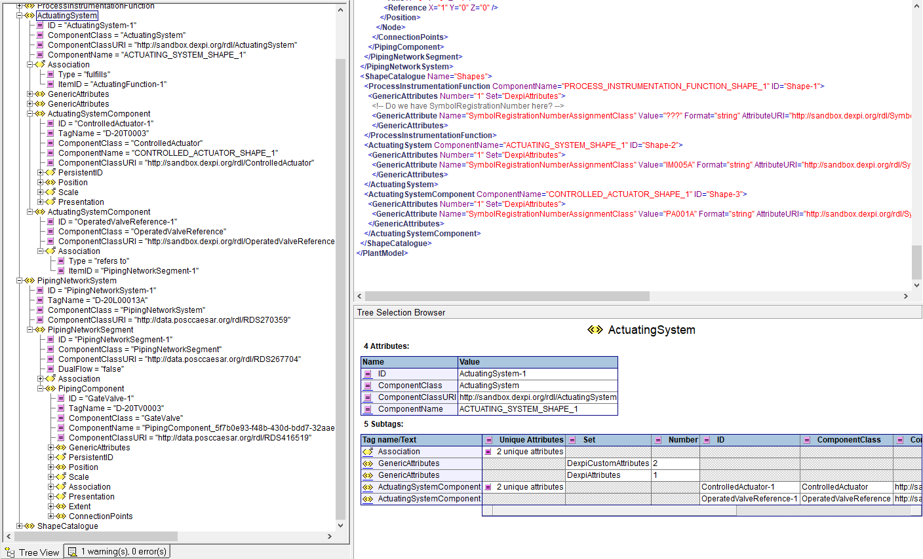
Figure 21: Proteus Implementation Actuated Valve (Ref: included example file ‘ActuatedValve_Example.xml’)

Requirement Details:
- InstrumentationLoopFunction class association for an actuated valve shall be via the associated ProcessInstrumentationFunction object Ref: Figure 20: DEXPI Actuated Valve model example.
- DEXPI ActuatingFunction shall have an associated SignalConveyingFunction. The ActuatingFunction shall be the Target of the SignalConveyingFunction.
- The OperatedValve (or subtype) class shall contain the information relevant for the tag.
- The OperatedValve (or subtype) class element shall ‘own’ the link to the label for this item type.
- For each Actuator (ControlledActuator) DEXPI transfer object represented by a symbol with an type code text component shall include the following attribute:
Attribute | RDS | Value Example | Comment
TypeCode | http://noaka.org/rdl/TypeCodeAssignmentClass | M | Text code to be displayed within the symbol. Ref: [7] ‘Label Attributes’
FailAction | http://sandbox.dexpi.org/rdl/FailActionSpecialization | FC | Fail Action code associated with the actuator.

Equipment Box
Equipment box shall not be transferred.
This section has been left as a reference in the event that the project determines it is necessary to transfer equipment box information.
Equipment Box/Table is the addition of a tabulated list of attribute name and value pairs that are associated with an equipment shown on the P&ID. The extent of the requirements for this list of attributes shall be as per the project requirements. The Equipment box transfer will be managed similarly to the symbol transfer via a reference ID.

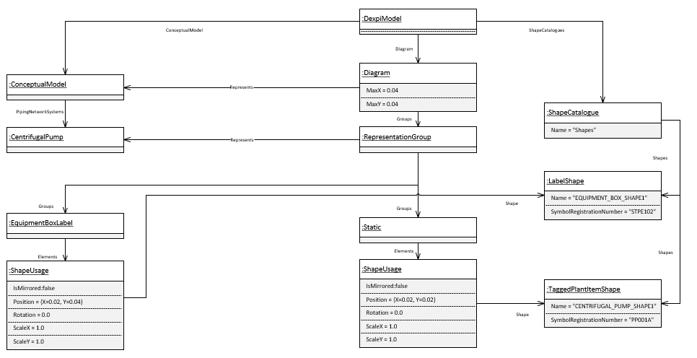
Figure 22: DEXPI Equipment box model example

Requirement Details:
- Any attributes that are shown in the equipment box shall be transferred with the associated item in the transfer file.
- During the project only Tag Name and Description are required to be transferred using the DEXPI attribute definitions below:

Attribute | RDS | Value Example | Comment
TagName | http://sandbox.dexpi.org/rdl/TagNameAssignmentClass | D-20PA001 | Tag name as stored in the tag register system.
EquipmentDescription | http://data.posccaesar.org/rdl/RDS2181987301 | GEAR PUMP | Functional service description of the tagged item.

Equipment Internals
Process Column / Vessel internals to be added as new request.

Labels
DISC DEXPI requirements define that for most object symbols the label will form part of the overall graphical representation Ref: [7] ‘Label Attributes’. For other object types the information for that object may be displayed in an associated label symbol e.g. for Off-line Instruments. For this type of label the DEXPI and Proteus representation is provided: Ref: (Figure 5: DEXPI model example Safety Valve Label Symbol Reference) where the link between the object and the label is via the ComponentName attribute.
In addition to these types, information for the object may also be provided as a text string naming label related to the object e.g. for piping ‘PipingNetworkSystem’. In this case the label exported as a direct child object of the piping class element and refers by default to ‘ObjectDisplayName’ as the default attribute used for label text.
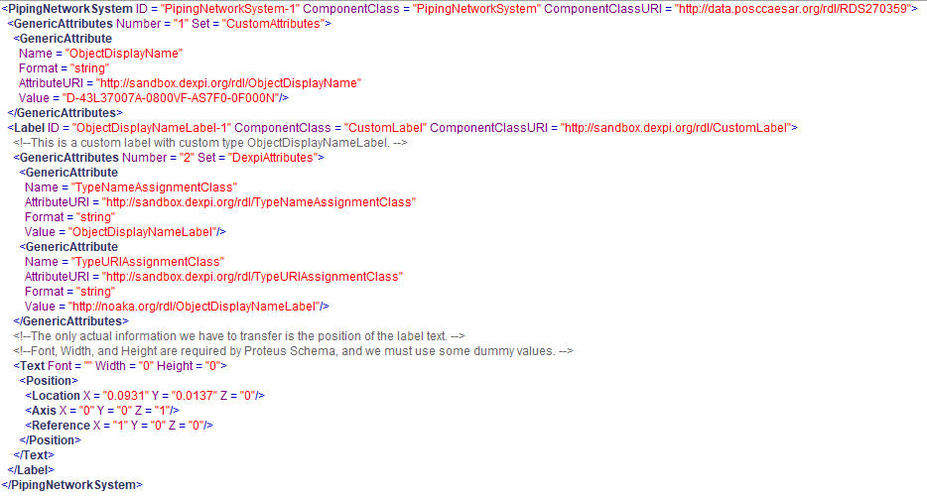
Figure 23: Proteus implementation for the PipingNetworkSystem naming label

Note
Note is the text added to the P&ID to provide additional information about an item or items on the drawing. Each note shall be linked to at least one item on the drawing, however, the modelling described below will allow for notes that are not connected. An item on the drawing can have more than one note.
DEXPI standard does not currently contain a note class element, this has been identified as a gap within DEXPI. A suggestion has been provided to the DEXPI content group regarding the introduction of a new ‘Note’ class element as a direct child of the Conceptual Model, this suggestion has been approved for release in the next version of the DEXPI standard. It has also been approved for use within the DISC DEXPI project and adjustments to the DEXPI verificator will be made accordingly to ensure that this new class type does not produce verification errors.
Ref: Error! Reference source not found.
Ref: Protues Example

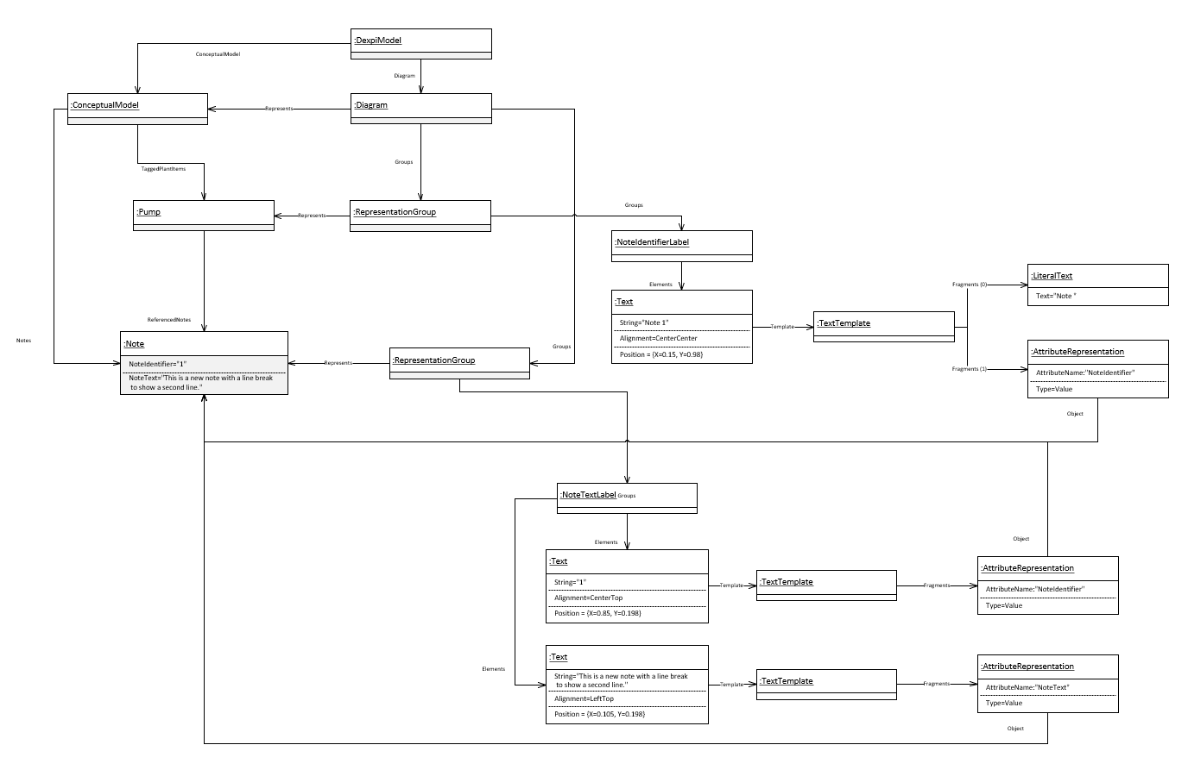
Figure 24: DISC DEXPI Notes model example
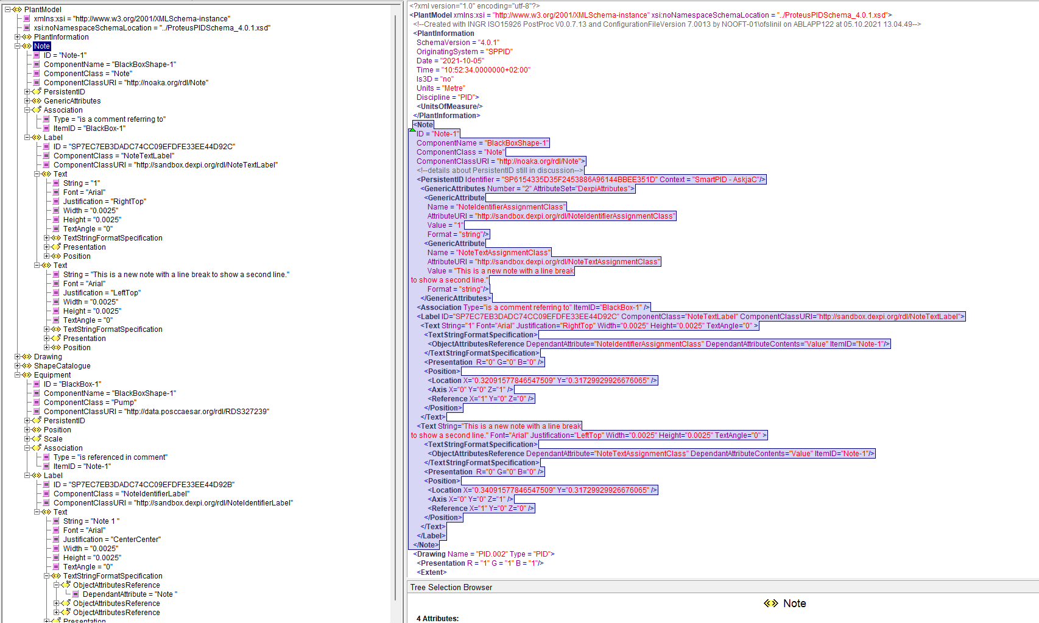
Figure 25: Proteus Implementation DISC DEXPI Notes example (Ref: included example file ‘NoteDEXPISuggestion.xml’)

Requirement Details:
- Each note shall have a PersistentID
- For each Note DEXPI transfer object shall include the following attributes (which will be considered as Dexpi attributes and not custom attributes in this project):

Attribute | RDS | Value Example | Comment
NoteIdentifier | http://sandbox.dexpi.org/rdl/NoteIdentifierAssignmentClass | 1 | Note reference ID
NoteText | http://sandbox.dexpi.org/rdl/NoteTextAssignmentClass | This is a note text | Note text
NoteClassification | http://sandbox.dexpi.org/rdl/NoteClassificationAssignmentClass | Technical Requirement | Note classification

Miscellaneous Graphics

Graphics Items with Symbol Reference
The following section contains details for those miscellaneous elements that are modelled within DEXPI 2.0 standard and are defined with a symbol reference.

PropertyBreak
Property break graphic shall be used to represent the break of ‘one’ attribute only i.e. each break type shall be represented by a separate property break graphic.
The type of break being represented by the property break graphic shall be identified by setting the associated property break attribute as defined below. The graphic shall display the ‘break’ attribute from the pipeline on either side of the property break graphic.
Ref: Protues Example
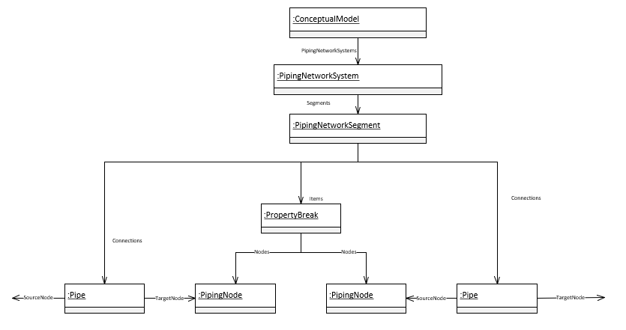
Figure 26: DEXPI PropertyBreak model example

Requirement Details:
- A PropertyBreak element is required to have the same x,y ordinate values for both process nodes as the PropertyBreak represents a single point.
- Each PropertyBeak DEXPI transfer object shall use the following attributes to identify the type of property break:

Attribute | RDS | Transfer Value | Value RDS
AreaBreak | http://noaka.org/rdl/AreaBreakAssignmentClass | AreaBreak | NA
HeatTracingBreak | http://noaka.org/rdl/HeatTracingBreakAssignmentClass | HeatTracingBreak | NA
InsulationBreak | http://sandbox.dexpi.org/rdl/InsulationBreakSpecialization | InsulationBreak | http://sandbox.dexpi.org/rdl/InsulationBreak
NominalDiameterBreak | http://sandbox.dexpi.org/rdl/NominalDiameterBreakSpecialization | NominalDiameterBreak | http://sandbox.dexpi.org/rdl/NominalDiameterBreak
PipingClassBreak | http://sandbox.dexpi.org/rdl/PipingClassBreakSpecialization | PipingClassBreak | http://sandbox.dexpi.org/rdl/PipingClassBreak
ContractorBreak | http://noaka.org/rdl/ContractorBreakAssignmentClass | ContractorBreak | NA
CommissioningBreak | http://noaka.org/rdl/CommissioningBreakAssignmentClass | CommissioningBreak | NA
PipingInstrumentBreak | http://noaka.org/rdl/PipingInstrumentBreakAssignmentClass | PipingInstrumentBreak | NA
LineIDBreak | http://noaka.org/rdl/LineIDBreakAssignmentClass | LineIDBreak | NA
BreakValue1 | http://noaka.org/rdl/BreakValue1AssignmentClass | Text for downstream or first break value
BreakValue2 | http://noaka.org/rdl/BreakValue2AssignmentClass | Text for upstream or second break value

Piping Off Page Connector (Out)
Piping Off Page Connector (OPC) graphic shall be used to represent a pipeline that continues elsewhere either on the same drawing or on another drawing with the flow direction ‘out’.
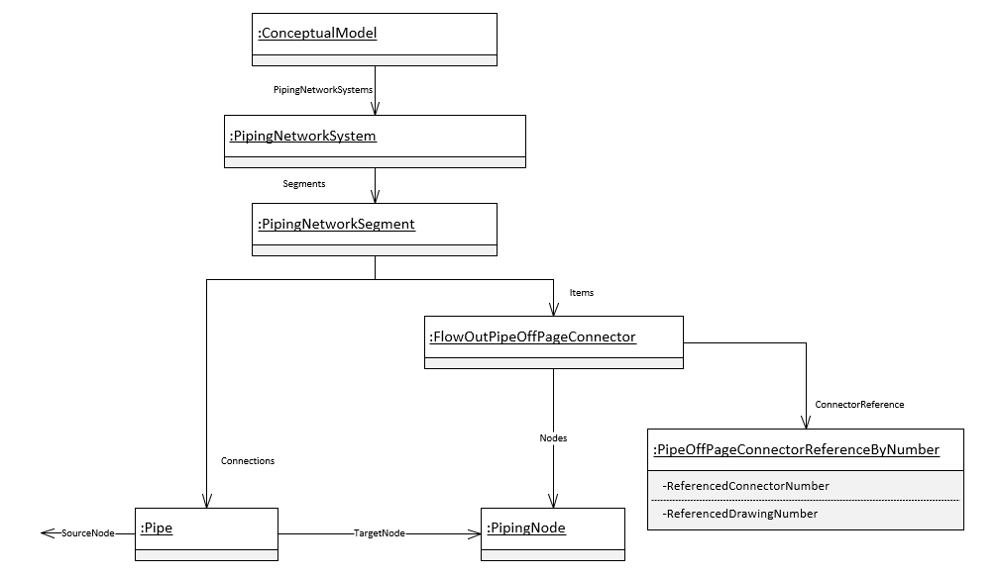
Figure 27: DEXPI FlowOutPipeOffPageConnector model example

Requirement Details:
- The piping off page connector (Flow Out) shall use the correct symbol to indicate flow direction ‘out’ to the side dependant on which side of the drawing the graphic is placed.
- Each FlowOutPipeOffPageConnector shall be transferred with an associated PipeOffPageConnectorReferenceByNumber DEXPI transfer object as per the figure above.
- Each PipeOffPageConnectorReferenceByNumber DEXPI transfer object shall include the following attributes when available:

Attribute | RDS | Value Example | Comment
ReferencedConnectorNumber | http://sandbox.dexpi.org/rdl/ReferencedConnectorNumberAssignmentClass | TBD | The unique key used to match this connector with its matching counterpart.
ReferencedDrawingNumber | http://sandbox.dexpi.org/rdl/ReferencedDrawingNumberAssignmentClass | TBD | The Name attribute of the Drawing that the matching ConnectorSymbol is on.
ReferencedDrawingDescriptor | http://noaka.org/rdl/ReferencedDrawingDescriptorAssignmentClass | CLOSED DRAIN | Typically the title of the referenced drawing.

Piping Off Page Connector (In)
Piping Off Page Connector (OPC) graphic shall be used to represent a pipeline that continues elsewhere either on the same drawing or on another drawing with the flow direction ‘in’.
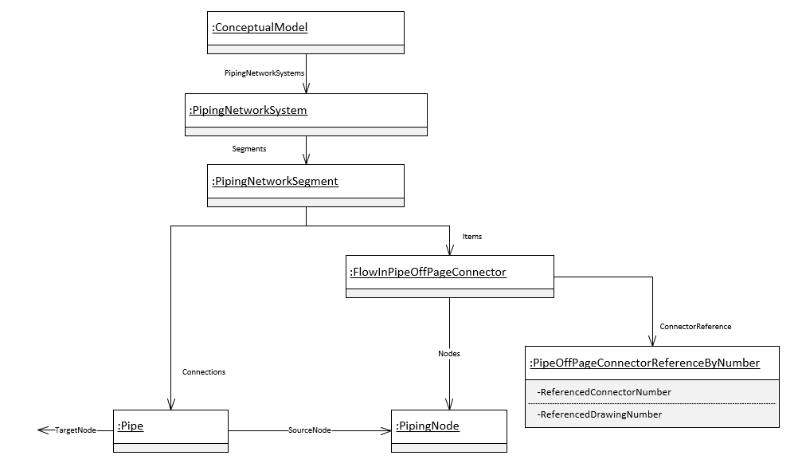
Figure 28: DEXPI FlowInPipeOffPageConnector model example

Requirement Details:
- The piping off page connector (Flow In) shall use the correct symbol to indicate flow direction ‘in’ from the side dependant on which side of the drawing the graphic is placed.
- Each FlowInPipeOffPageConnector shall be transferred with an associated PipeOffPageConnectorReferenceByNumber DEXPI transfer object as per the figure above.
- Each PipeOffPageConnectorReferenceByNumber DEXPI transfer object shall include the following attributes when available:

Attribute | RDS |  | Value Example |  | Comment
ReferencedConnectorNumber | http://sandbox.dexpi.org/rdl/ReferencedConnectorNumberAssignmentClass |  | TBD |  | The unique key used to match this connector with its matching counterpart.
ReferencedDrawingNumber | http://sandbox.dexpi.org/rdl/ReferencedDrawingNumberAssignmentClass |  | TBD |  | The Name attribute of the Drawing that the matching ConnectorSymbol is on.
ReferencedDrawingDescriptor | http://noaka.org/rdl/ReferencedDrawingDescriptorAssignmentClass | CLOSED DRAIN |  | Typically the title of the referenced drawing.

Piping Off Page Connector where flow is bi-directional or unknown
Where the flow is bi-directional or unknown the export tool shall manage the paired connectors for the pipe such that one connector is defined as ‘Flow Out’ and the other connector is defined as ‘Flow In’ as per the definitions above (Ref: Piping Off Page Connector (Out) and Piping Off Page Connector (In)). The symbol used to show the connector in this case is not related to flow direction.

Signal Off Page Connector (Out)
Signal Off Page Connector (OPC) graphic shall be used to represent a signal that continues elsewhere either on the same drawing or on another drawing with the flow direction ‘out’.
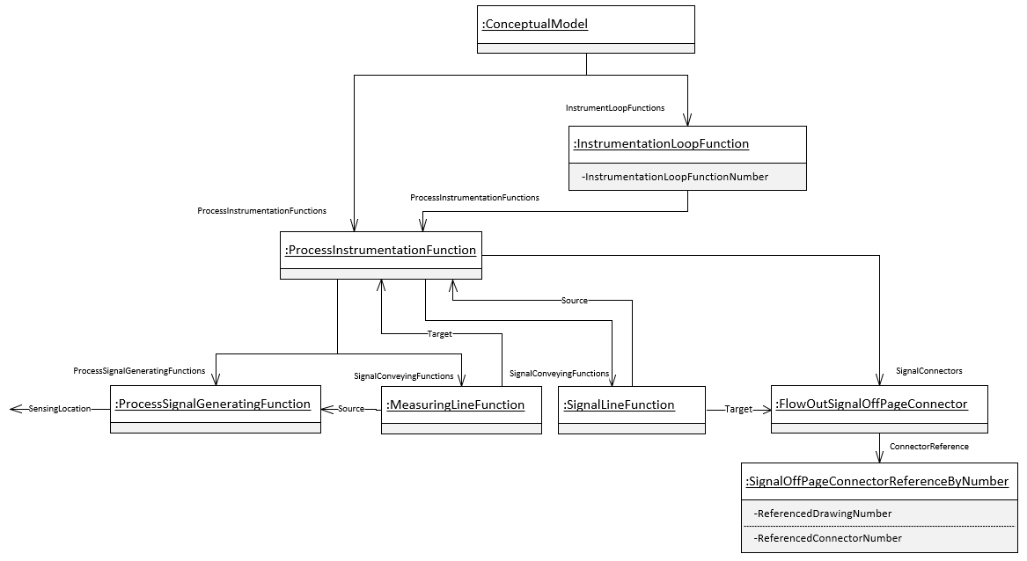
Figure 29: DEXPI FlowOutSignalOffPageConnector model example

Requirement Details:
- The signal off page connector (Flow Out) shall use the correct symbol to indicate flow direction out dependant on which side of the drawing the graphic is placed.
- Each FlowOutSignalOffPageConnector shall be transferred with an associated SignalOffPageConnectorReferenceByNumber DEXPI transfer object as per the figure above.
- Each SignalOffPageConnectorReferenceByNumber DEXPI transfer object shall include the following attributes when available:

Attribute | RDS |  | Value Example |  | Comment
ReferencedConnectorNumber | http://sandbox.dexpi.org/rdl/ReferencedConnectorNumberAssignmentClass |  | TBD |  | The unique key used to match this connector with its matching counterpart.
ReferencedDrawingNumber | http://sandbox.dexpi.org/rdl/ReferencedDrawingNumberAssignmentClass |  | TBD |  | The Name attribute of the Drawing that the matching ConnectorSymbol is on.
ReferencedDrawingDescriptor | http://noaka.org/rdl/ReferencedDrawingDescriptorAssignmentClass | CLOSED DRAIN |  | Typically the title of the referenced drawing.

Signal Off Page Connector (In)
Signal Off Page Connector (OPC) graphic shall be used to represent a signal that continues elsewhere either on the same drawing or on another drawing with the flow direction ‘in’.
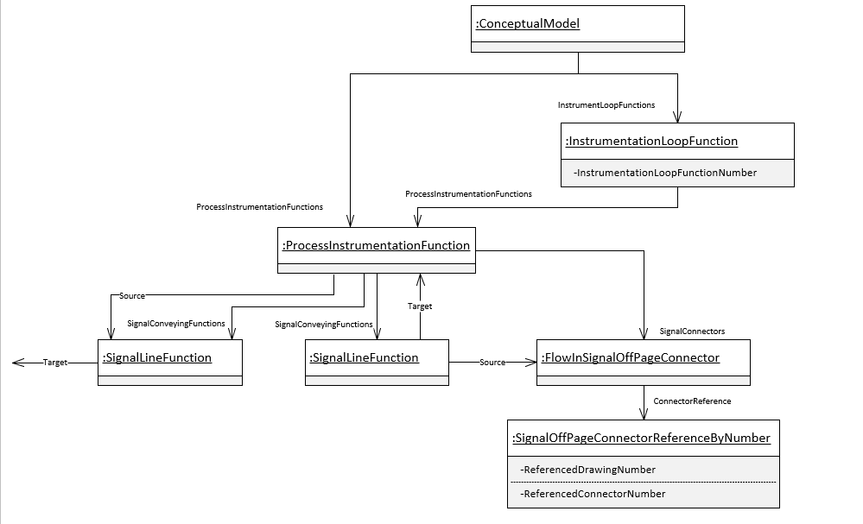
Figure 30: DEXPI FlowInSignalOffPageConnector model example

Requirement Details:
- The signal off page connector (Flow In) shall use the correct symbol to indicate flow direction in dependant on which side of the drawing the graphic is placed.
- Each FlowInSignalOffPageConnector shall be transferred with an associated SignalOffPageConnectorReferenceByNumber DEXPI transfer object as per the figure above.
- Each SignalOffPageConnectorReferenceByNumber DEXPI transfer object shall include the following attributes when available:

Attribute | RDS |  | Value Example |  | Comment
ReferencedConnectorNumber | http://sandbox.dexpi.org/rdl/ReferencedConnectorNumberAssignmentClass |  | TBD |  | The unique key used to match this connector with its matching counterpart.
ReferencedDrawingNumber | http://sandbox.dexpi.org/rdl/ReferencedDrawingNumberAssignmentClass |  | TBD |  | The Name attribute of the Drawing that the matching ConnectorSymbol is on.
ReferencedDrawingDescriptor | http://noaka.org/rdl/ReferencedDrawingDescriptorAssignmentClass | CLOSED DRAIN |  | Typically the title of the referenced drawing.

Signal Off Page Connector unknown flow direction
Signal Off Page Connectors typically do not store a flow direction and for this reason the tool shall manage the paired connectors for the signal such that one connector is defined as ‘Flow Out’ and the other connector is defined as ‘Flow In’ as per the definitions above (Ref: Signal Off Page Connector (Out) and Signal Off Page Connector (In)). The symbol used to show the connector in this case is not related to flow direction.

Slope
Pipeline slope graphic shall be used to represent the slope for the pipeline.
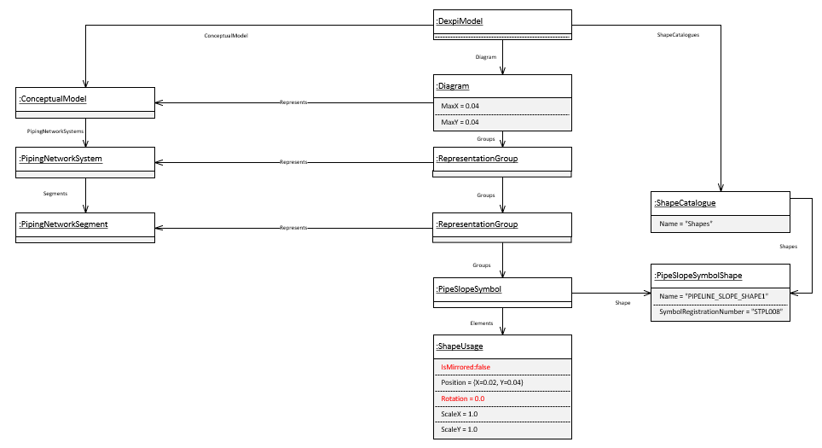
Figure 31: DEXPI Slope model example

Requirement Details:
- The pipeline slope graphic shall use the ‘PipeSlopeSymbol’ type as per the model example above.
- The pipeline slope graphic shall reference the SymbolRegistrationNumber ‘STPL008’ within the transfer file as per the model example above.
- The association between the PipingNetworkSegment and the pipeline slope graphic shall be provided in the DEXPI transfer file following the model example above.

Piping Flow Direction Arrow
Pipeline flow direction arrow graphic shall be used to represent the flow direction for the pipe.
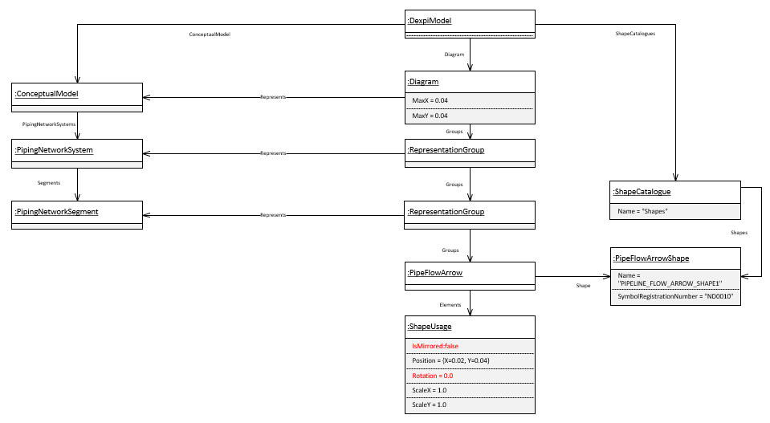
Figure 32: DEXPI Slope model example

Requirement Details:
- The pipeline flow arrow graphic shall use the ‘PipeFlowArrow’ type as per the model example above.
- The pipeline flow arrow graphic shall reference the SymbolRegistrationNumber ‘ND0010’ within the transfer file as per the model example above.
- The association between the PipingNetworkSegment and the pipeline flow arrow graphic shall be provided in the DEXPI transfer file following the model example above.

Radio-active target/source identification symbol
Radioactive symbol is used to identify a radioactive source or target object.
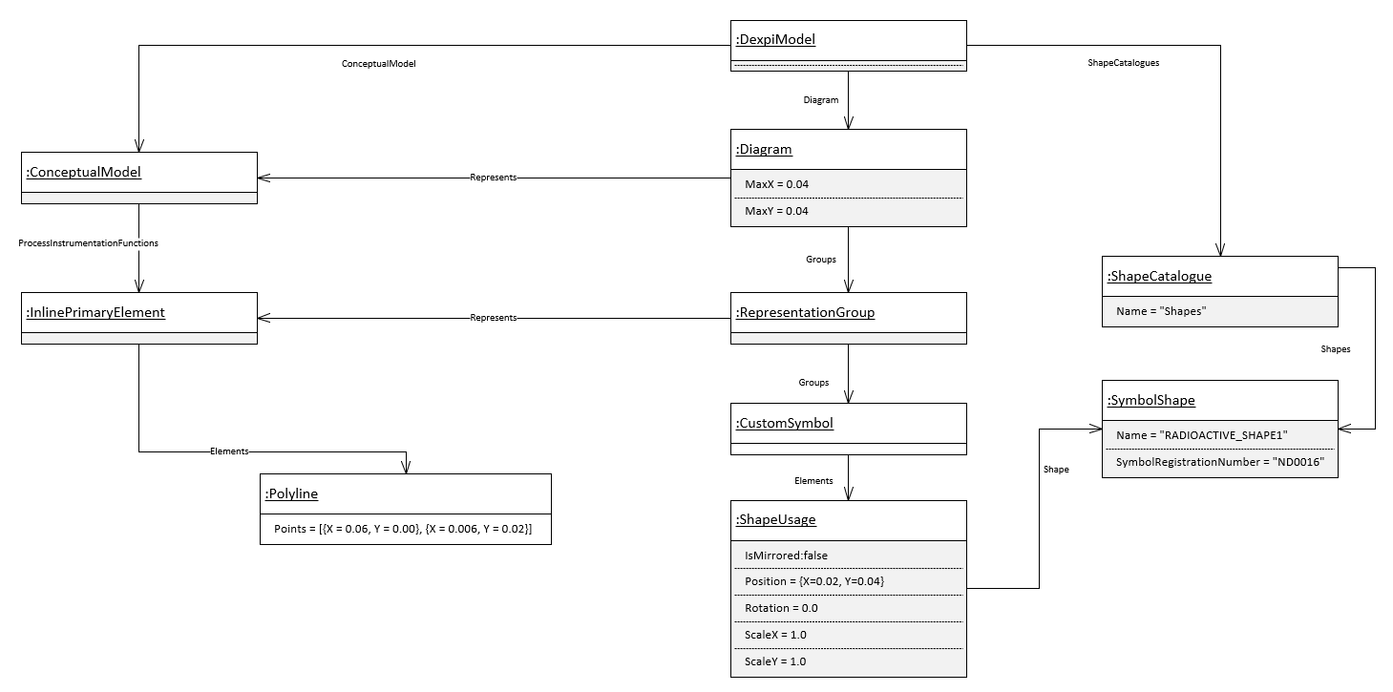
Figure 33: Radioactive symbol DEXPI model example

Requirement Details:
- The association between the ConceptualObject and the radioactive graphic shall be provided in the DEXPI transfer file following the model example above.

Graphics Items Without Symbol Reference
The following section details any special requirements regarding graphical elements that are not represented by a symbol.

Pipe
Pipe elements are represented in DEXPI as a connection between points: ConnectorLine InnerPoints and/or PipingNodePosition Position points.
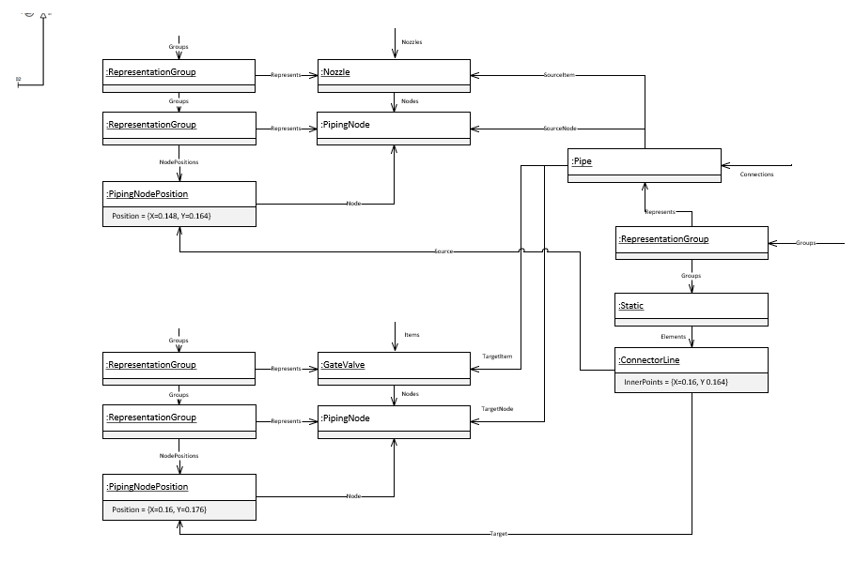
Figure 34: DEXPI Pipe with angle model example

Requirement Details:
- The PipingNodePosition Position point of the connected PipingNode shall represent a point on the PipingNodeOwner e.g. GateValve / Nozzle

Leader Lines
Leader lines are represented in DEXPI as a polyline with an ordered set of points depicting the start, end and any intermediate points of the line.

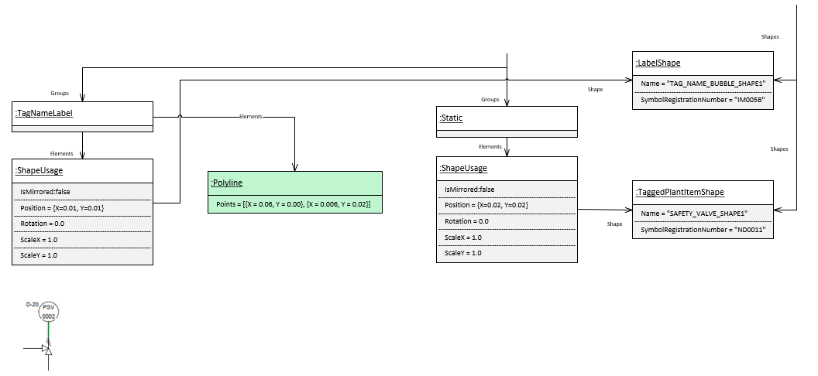
Figure 35: Leader line graphic representation example

Requirement Details:
- Leader lines shall be ‘owned’ by the label as shown above.

Elevation
Ref: Protues Example
Elevation is represented in DEXPI as a polyline with an ordered set of points depicting the start, end and any intermediate points of the line.

Figure 36: Leader line graphic representation example
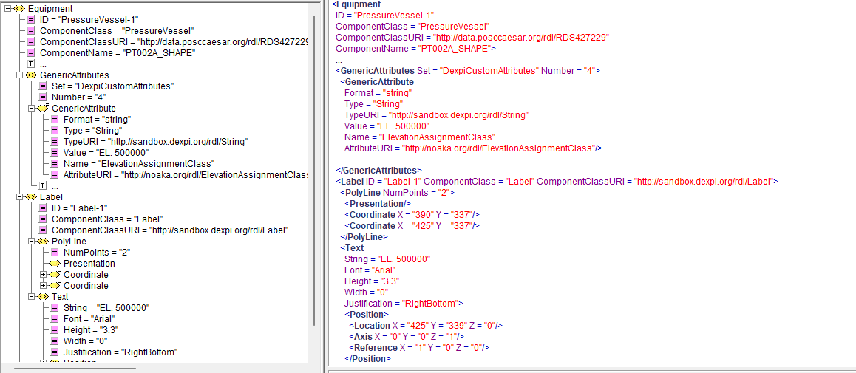
Figure 37: Proteus Implementation Elevation (Ref: included example file ‘Elevation_Example.xml’)

Requirement Details:
- Leader lines shall be ‘owned’ by the label as shown above.

ANNEX A: Custom class definitions - Non Graphical Elements
The following section details the special custom class definitions without graphics that shall be available within the DISC DEXPI profile for verification within the project.
Additional custom class definitions for graphically represented objects can be found in the Symbol legend Ref: [7]

Virtual Piping Connector
VirtualPipingConnector type is defined as a special piping connector type. This connector type is required in the case where the P&ID shows two pipes connecting directly with each other i.e., there is no graphical representation of a connecting piping compontent between the two pipes shown on the P&ID.
This type has a Supertype ‘PipingNodeOwner’ and thus provides the necessary PipingNode connection points between PipingNetworkSegments.
This type has no graphical representation.

Requirement Details:
- Each CustomPipingComponet (VirtualPipingConnector) DEXPI transfer object shall use the following attributes to identify the type of property break:

Attribute | RDS | Transfer Value | Value RDS
TypeName | http://sandbox.dexpi.org/rdl/TypeNameAssignmentClass | VirtualPipingConnector
TypeURI | http://sandbox.dexpi.org/rdl/TypeURIAssignmentClass | http://sandbox.dexpi.org/rdl/VirtualPipingConnector | NA

Virtual Instrumentation Connector
VirtualInstrumentationConnector type is defined as a special instrument/piping connector type. This connector type is required in the case where the P&ID shows an instrument connecting directly with a pipe i.e., there is no graphical representation of a connecting piping compontent between the instrument and the pipe shown on the P&ID.
This type has a Supertype ‘PipingNodeOwner’ and thus provides the necessary PipingNode connection points between PipingNetworkSegments.
This type has no graphical representation.

Requirement Details:
- Each CustomPipingComponet (VirtualInstrumentationConnector) DEXPI transfer object shall use the following attributes to identify the type of property break:

Attribute | RDS | Transfer Value | Value RDS
TypeName | http://sandbox.dexpi.org/rdl/TypeNameAssignmentClass | VirtualInstrumentationConnector
TypeURI | http://sandbox.dexpi.org/rdl/TypeURIAssignmentClass | http://sandbox.dexpi.org/rdl/VirtualInstrumentationConnector | NA

ANNEX B: Custom attribute defintions
Refer to DISC DEXPI Symbol legend file Ref: [7]

ANNEX C: Draft update ‘P&ID Profile file specification 3.3.3’
(Ref: [8]) Section 2.2.1 for DEXPI 2.0)
PipingNetworkSegment Topology (Connection element)
Components within a PipingNetworkSegment are considered to be implicitly connected, by their main flow in and flow out connections points, in the order that they are represented in the PipingNetworkSegment. This ordering may differ between a P&ID and 3D model.

Each PipingNetworkSegment is a collection of PipingNetworkSegmentItems (e.g., PipingComponents such as Valves) and PipingConnections (e.g., Pipes) with common engineering properties that define a single process flow. Where there is a junction in the flow or a change of specification (e.g., piping class or nominal diameter), the PipingNetworkSegment will terminate.

A PipingNetworkSegment, as its SourceItem, will reference a Nozzle, PipingComponent, or PropertyBreak that it doesn’t contain or it will reference a FlowInPipeOffPageConnector that it contains.
Connection from :
Nozzle
PipingComponent
PropertyBreak

PipingNetworkSegment

…
PipingNetworkSegment

FlowInPipeOffPageConnector
…
Connection from :
FlowInPipeOffPageConnector

A PipingNetworkSegment, as its TargetItem, will reference a Nozzle, merging component (a PipingComponent such as a Tee) that it doesn’t contain or it will reference a PipingComponent, PropertyBreak, or FlowOutPipeOffPageConnector that it contains as its last component.
PipingNetworkSegment

PipingNetworkSegment
Connection to :
Nozzle
Merging component

…
PipeConnectorSymbol
Reducer
Splitting Component
…
Connection to :
PipingComponent, PropertyBreak
FlowOutPipeOffPageConnector

If the TargetItem of a PipingNetworkSegment is a contained PipingNetworkSegmentItem, the TargetNode of the PipingNetworkSegment is the main downstream PipingNode of this PipingNetworkSegmentItem, if applicable (i.e. the main flow out of the segment).

ANNEX D: Symbol Rotation and mirroring - example
The following table shows the rotation and mirroring of an example symbol and demonstrates that mirroring the base symbol (shown in RED) on the Y-axis and then rotating 180º provides the same result as if the base symbol had been mirrored on the X-Axis. ** scaling before rotation.
Ref: Protues Example
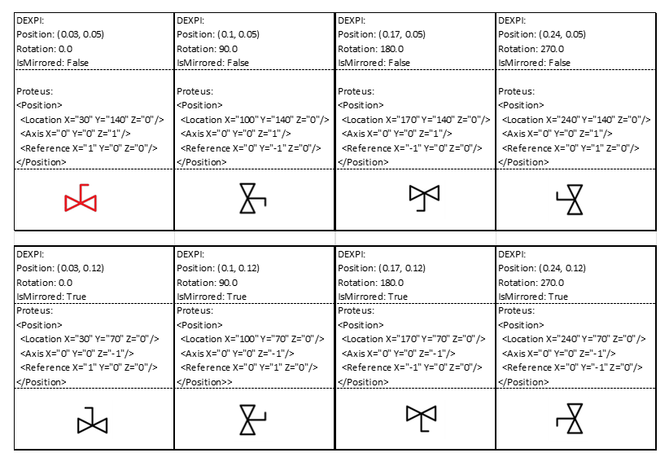
Figure 38: Symbol Rotation Attribute Example

Rotation and Mirroring in DEXPI and Proteus

DEXPI
- geometry unit: m (because SI base unit)
- axes and rotation like in SVG:
  - horizontal axis (x): left to right
  - vertical axis (y): top to bottom
  - rotation: in degrees, clockwise
- meaning of ShapeUsage attributes (note the order: in particular: scaling before rotation):
  - ScaleX, ScaleY: shape is scaled along x and y axis w.r.t. its origo (0, 0)
  - if IsMirrored: shape is mirrored at y axis (x=0)
  - Rotation: around (0, 0), in degrees, clockwise
  - Position: shape is translated such that its origo (0, 0) is translated to Position

Proteus
- geometry unit: given in <PlantInformation>, e.g., m or mm
- axes and rotation:
  - horizontal axis (x): left to right
  - vertical axis (y): bottom to top
  - rotation: in degrees, counterclockwise
- <Position> contains
  - <Location> = Position in DEXPI
  - <Axis> and <Reference> correspond to DEXPI Rotation and IsMirrored
    - <Axis> is rotation axis
we allow only rotation around third (z) axis:
      - <Axis X="0" Y="0" Z="1"/> means “not mirrorred”
      - <Axis X="0" Y="0" Z="-1"/> means “mirrored”
    - <Reference> is unit vector describing rotation of α around rotation axis:
      - <Reference X=”cos α”, Y=”sin α”, Z=0>
      - note that rotation axis has opposite direction if “mirrored”!

ANNEX E: Signal conveying Line Types
Refer to DISC DEXPI Symbol legend file Ref: [7]

ANNEX F: Valve Label Details

The attributes available within valve labels shall be determined based on whether the valve symbol is used to show a manual valve or an on/off actuated or controlled valve. Attribute details for the valve label is defined in the symbol legend details (Ref: [7]) using the attribute formats below.

- Manual Valves
A space character shall be used between the trim and lock mechanism attributes as shown.
<ObjectDisplayName>
<NominalDiameter><VDS>
<TrimType> <LockMechanism>

- On/Off Actuated or Controlled Valves
A space character shall be used between the trim and lock mechanism attributes as shown.
<NominalDiameter><VDS>
<TrimType> <LockMechanism>
Additional Notes:
- Valve Normal Position is no longer required to be shown in the label. Normal Position will be indicated by the symbol used e.g. black closed , white open
- Failure action is required to be shown in the label for the actuator if available Ref: [7]
- “Barrier information is not required in the label as this will be shown as part of the graphic” referring to DIB valves (examples below) and “Barrier information” the DP and SR notations. The following DIB valves will be added to the DISC DEXPI symbol legend soon.
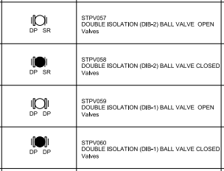
Figure 39: Valve Barrier variants

ANNEX G: Proteus Connection Points & Associations

Piping Connector
Within the piping system the piping connectors as defined by the conceptual DEXPI model have a 1:1 mapping with the graphical model. This allows the standard to simplify the export and NOT require the use of Associations to define relationships between conceptual elements, as this is already provided in Proteus export via graphical connections where:
- Node Type=’Process’ for piping ConnectionPoints Nodes
- Proteus XML Node element belonging to the ConnectionPoints XML node for the connected element represents the PipingNode conceptual element of the graphically represented element (has a SymbolReferenceID)
- The Proteus PipingNetworkSegment CenterLine child coordinates together with the coordinates of the nodes of the graphically connected elements provides the graphical connection information for the piping connectors.
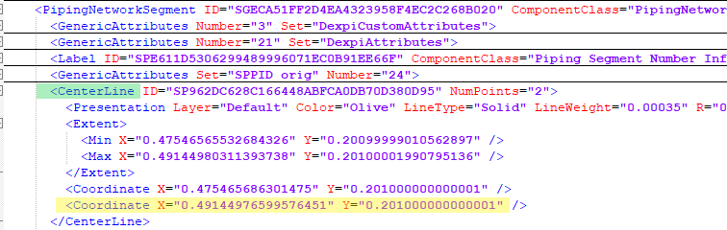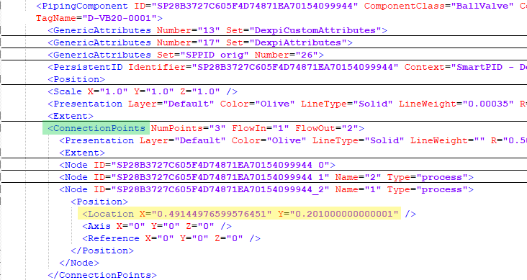

- Link between PipingNetworkSegment Connection From/To* Node & PipingNodeOwner: ConnectionPoints / Node**
* From/ToNode is not required where the connection is to a Nozzle
** based on node (zero-based) index of PipingNodeOwner / Connection Points
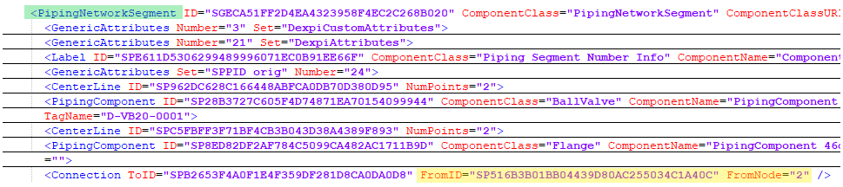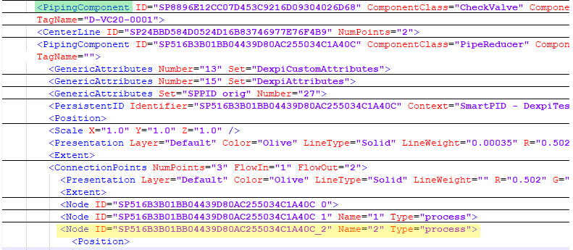

Instrument Connector
For Instrumentation connections the conceptual model as defined by DEXPI is not a 1:1 mapping to the graphical representation of the connection and therefor the standard requires the use of Associations to define relationships between conceptual elements in addition to the graphical representation of the connections where:
- Node Type=’Signal’ for instrument ConnectionPoints Nodes
- Proteus XML Node element belonging to the ConnectionPoints XML node for the connected element represents the graphical connection points for the graphically represented element (has a SymbolReferenceID)
- Proteus InformationFlow has associations ‘has logical end’ & ‘has logical start’ to define the conceptual model element connections.
  - Where the connected conceptual element will have the association ‘is logical end of’ or ‘is logical start of’
- The Proteus InformationFlow CenterLine child coordinates together with the coordinates of the nodes of the graphically connected elements provides the graphical connection information for the instrumentation connectors.
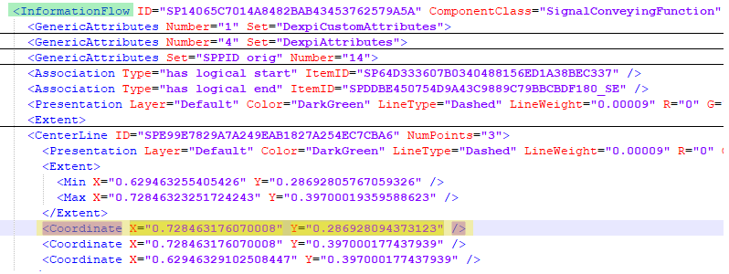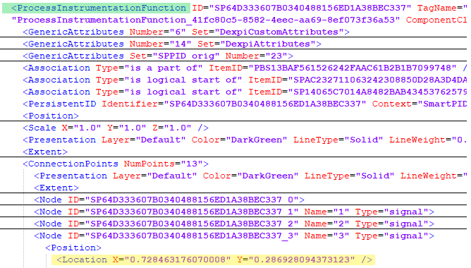

- When the Proteus InformationFlow has ComponentClass=’MeasuringLineFunction’ it is required that the related ProcessSignalGeneratingFunction class element shall have an association ‘is located in’ to define the conceptual model element sensing connection.
  - Where the SensingLocation conceptual element (Nozzle, PipingComponent or PipingNetworkSegmenet) will have the association ‘is the location of’

